Magnet - a material or object that produces a magnetic field
Magnetic Field - a region of space around a magnet that causes a magnetic force on magnetic objects
Legend of Magnes
The discovery of magnets is attributed in legend to Magnes, a shepherd who lived in the area of Magnesia, Greece, over 4000 years ago. He was surprised one day when he stepped on a rock and the iron nails in his sandals stuck to it. This type of rock came to be known as magnetite.

Basic Properties of Magnets
- certain ends of pieces of magnetite would attract each other while others would repel each other

History of the Compass
- when a magnetite sliver is suspended on a string, it orients itself with Earth’s magnetic field
- since these slivers had two magnetic ends, they were labelled poles
- a compass needle is a permanent magnet
- the pole of the magnet that points toward Earth’s North magnetic pole is labelled __________,
the other pole is labelled ______________
- Unlike poles ______________ each other and like poles ______________ each other.
Note: The North pole attracts the North magnetized pole of the compass. What does this imply?

Magnetic Field Lines:
Magnetic fields exist in three dimensions surrounding a magnet and are more intense at the poles. Magnetic fields are invisible, but can be represented in diagrams with magnetic field lines. Magnetic field lines
- Point away from the north pole to the south pole outside a magnet, and from the south pole to the north pole inside a magnet.
- Never cross one another.
- Are closer together where the magnetic field is stronger.

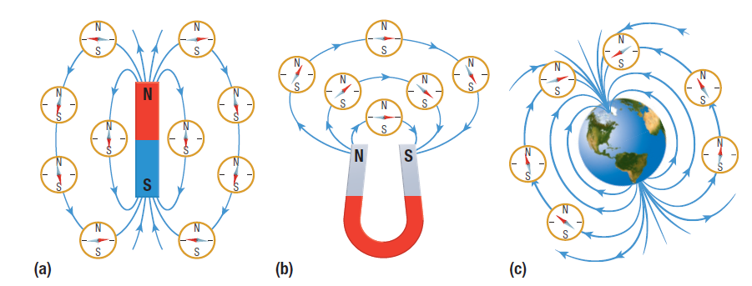
A compass can be used to map the direction of the field lines around a magnet. The compass needle will align itself along the direction of the field.

When the north pole of a magnet is brought near the south pole of another magnet, the two magnets attract each other. This happens because of the way the magnetic field of one magnet interacts with the magnetic field of the other magnet.
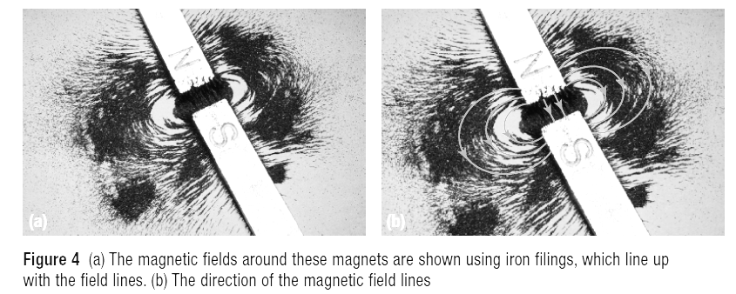
When two like poles are brought together, the magnets repel each other. This is because of the way the magnetic fields interact with each other.
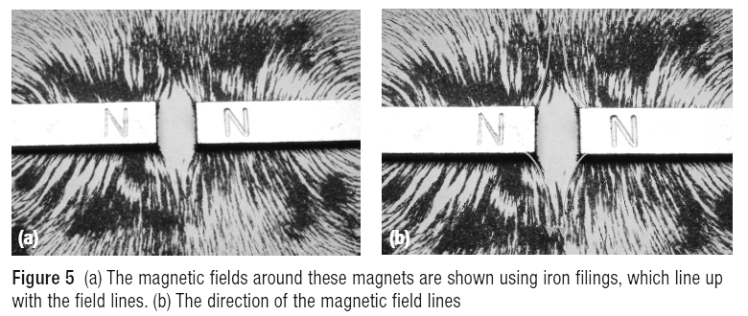
Domain Theory
According to domain theory, all large magnets are made up of smaller rotatable magnets, called dipoles (2 poles), which can interact with other dipoles. If dipoles line up, then a magnetic domain is produced. (No Monopole magnets!)
Types of Materials
Most materials will not react to a magnet. Some materials, such as iron, nickel, and cobalt do react and will always attract to a magnet. These materials are called ferromagnetic. When a magnet comes close to them, there dipoles rearrange and are attracted to the magnet.
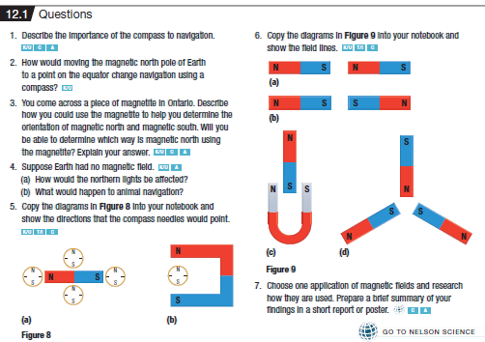

Connecting Electricity and Magnetism
In 1819, Danish physicist Hans Christian Oersted successfully connected electricity and magnetism.
- He held a compass near a wire in an electric circuit

- When a current was present in the wire, the compass needle was deflected perpendicular to the wire. When the current was switched off the needle went back to its original position.
- This led to the understanding of the shape of the magnetic field around a conductor.
Oersted’s Principle
Whenever a charge moves through a straight conductor, a circular magnetic field is created around the conductor
- The magnetic field surrounds the conductor in the shape of concentric circles.
- The direction of the field depends on the direction of the current.
- Reversing the current therefore reverses the direction of the magnetic field.
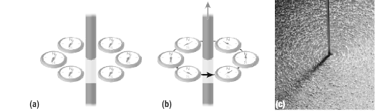
- Lastly, the strength of the magnetic field weakens as it moves further away from the conducting wire.

Applying Oersted’s Principle:
Right Hand Rule for a Straight Conductor. If a straight conductor is held in your right hand with your thumb pointing in the direction of the _____________________________________, your curled fingers will point in the direction of the magnetic field lines surrounding the conductor.
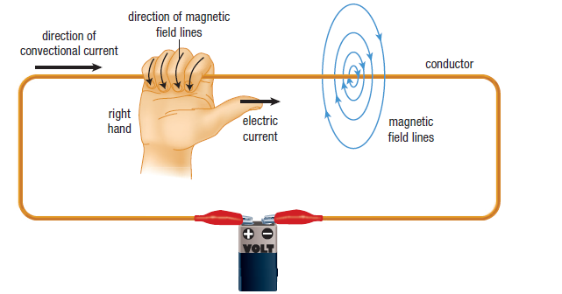
Representing Currents and Magnetic Fields:
- Current can go either into the page or out of the page.
- Conventional current going into the page we use an X
- Conventional current going out of the page we use a dot.

Example 1 Which direction is the conventional current flowing?

Example 2 You are driving East in your car. You drive underneath an electric wire which is perpendicular to the road. The wire is labelled high current. You notice that your compass displays your direction as north instead of East. In which direction is the conventional current flowing in the wire?

Ampere’s Experiment
- Inspired by Oersted, Andre-Marie Ampere took two parallel wires and conducted an experiment to see if the wires would attract or repel one another when opposing currents were sent through them.
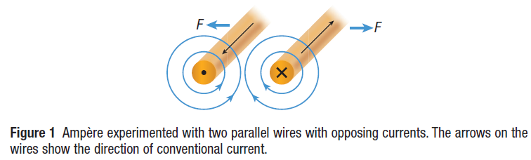

- We know that two magnetic fields can interact with each other to cause an attractive or repulsive force depending on the directions of the two interacting fields.
- If the field lines point in the same direction, we have a repulsive force. If the field lines are in opposing directions, we have an attractive force.
- Ampere hypothesized that having two parallel wires with opposing currents (meaning the field lines are going in the same directions) the wires should repel each other. Which of course they did.
- If two parallel wires have currents in the same direction they should ________________ each other.
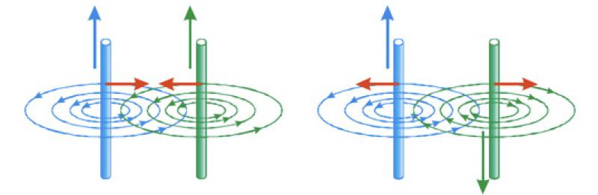

Homework: Read 17.2 pg. 584 #2 pg. 599 #2, 3, 5, 8, 20, 21

