Functional Group | Properties | Structural Formula | Example | Found in
Hydroxyl | Polar |  | 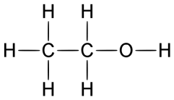  Ethanol | Carbohydrates, proteins, nucleic acids, lipids
Carbonyl | Polar |  | 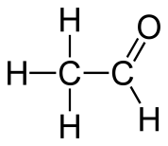  Acetaldehyde | Carbohydrates, nucleic acids
Carboxyl | Polar, acidic |  | 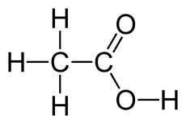  Acetic Acid | Proteins, lipids
Amino | Polar, basic |  | 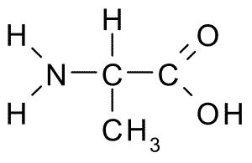  Alanine | Proteins, nucleic acids
Sulfhydryl | Slightly plolar |  | 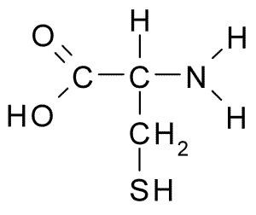  Cysteine | Proteins
Phosphate | Polar |  | 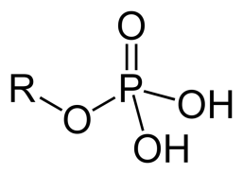  Glycerol Phosphate | Nucleic acids

Identification Strategies
- Look for OXYGEN – if absent go to step 2
- Single bonded OH HYDROXYL
- Double bonded
- If 2 oxygen CARBOXYL
- If 1 oxygen CARBONYL
- N present AMINO
- S present SULFYDRYL
- P present PHOSPHATE

Identify the functional groups in the following compounds:
