Data Analysis
In life there are many things that are related to other things. For example, the time it takes to do the dishes is related to: how dirty the dishes are, how many dishes there are, how you feel, how many helpers you have or how suitable the facilities and equipment are.The purpose of data analysis is to determine relationships between variables in an experiment. Methods of data analysts are always employed when large amounts of data are collected, Various methods of data analysis are continuously used in all branches of research science and in the business community.
Types of Variable
In a well controlled experiment there are usually only two variables:
- Independent variable
  - The experimenter chooses the values of this variable
  - This variable is always plotted on the Horizontal Axis

- Dependent variable
  - The experimenter measures the values of this variable
  - This dependent variable depends on the independent variable
  - This variable is always plotted on the Vertical Axis
Types of Relationships
- Direct Relationships

In a direct relationship, the increase in one variable causes an increase in the other variable. A special type of direct relationship is the Directly Proportional Relationship. In this type of relationship, if one variable is doubled, tripled or half, the same thing will occur to the other variable. If you plot a Directly Proportional Relationship you will always get a straight line.

y

X

- Indirect Relationship (Inverse Relationship)

In an indirect relationship the increases in one variable will cause a decrease in another variable. 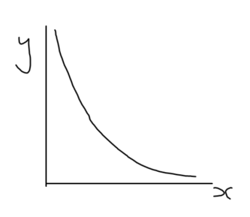
X
y

In this course we will only look at relationships having the form:
$$y∝x^{n}, or y=kx^{n} where k=constant$$
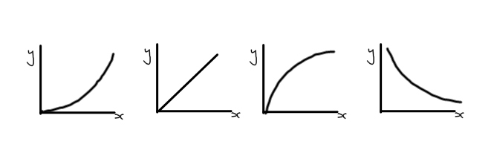
Proportionality
Your success with the methods of data analysis is dependent on your understanding of the concept of Proportionality. If two quantities are proportional, then they will produce a straight line when plotted on a graph. The slope of the graph is called the proportionality constant and is given the symbol k.
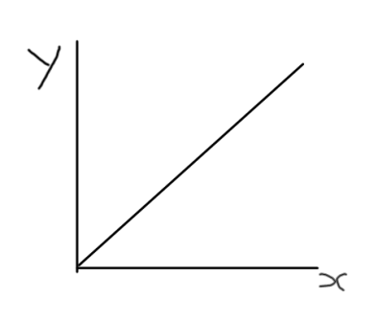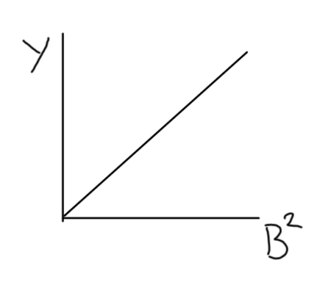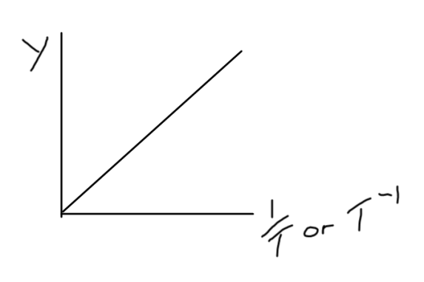
Data Analysis; Method 1 – Educated Guess Method
- Make a graph of the given data (x and y)
- Compare this graph to one of the known y = kx^{n} graphs and make an educated guess at the value of n.
- Create a new data table of y and x^{n} values.
- Plot a graph of y vs x^{n}.
- If the graph is a straight line then you have guessed the correct value of n and all you must do is calculate the slope of this graph (k) and state your result in the form of y = kx^{n}.
OR
If the graph is still a curve then you have not guessed the correct value of n. You must now guess a new value of n and repeat the process.

