Chemical Reactions

Anabolic Reactions:
  - Dehydration (Condensation) Synthesis

  - Formation of a Disaccharide

  - Formation of a Triglyceride Formation of a Protein
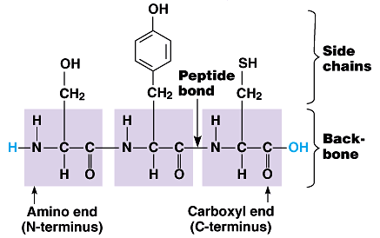
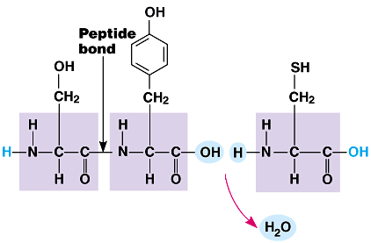

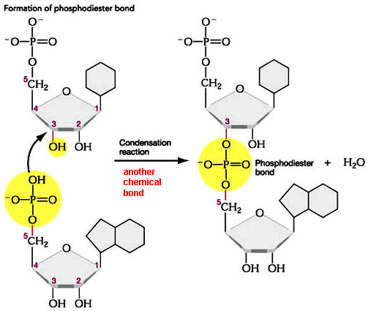
  - Formation of DNA

Catabolic Reactions:
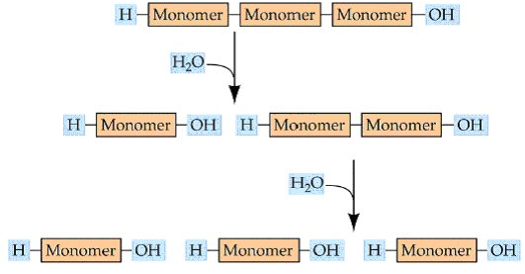
  - Hydrolysis

Oxidation Reduction (Redox) Reactions
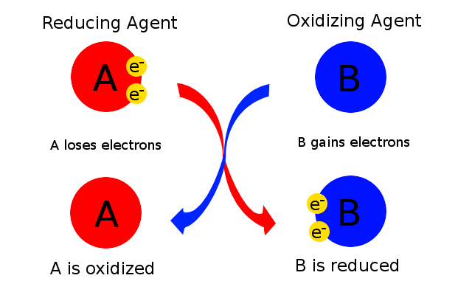

Buffers

Questions:
- Identify each of the following activities as either anabolic or catabolic:
- Protein synthesis
- Digestion
- DNA synthesis
- Photosynthesis
- Cellular respiration

- Differentiate between a hydrolysis reaction and a condensation reaction.

- Explain why a redox reaction must involve changes to two molecules simultaneously.

