## What is an Enzyme?



## Lock and Key Model



## What do Enzymes do?



## Why Use Enzymes?



## Enzyme-Substrate Complex



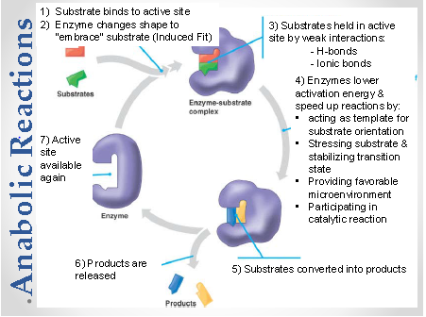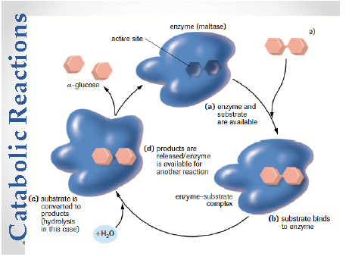

## Factors That Affect Enzyme Activity

3. 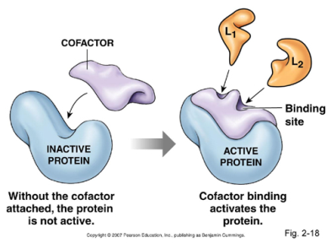

## Enzyme Cofactors



## Allosteric Regulation

* 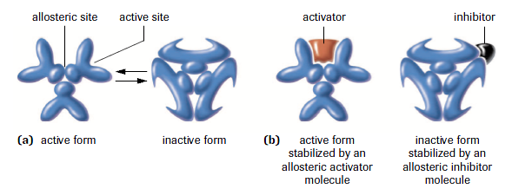

## Competitive Inhibitors

* 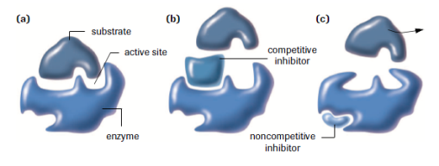

## Feedback Inhibition