Recall: There are three ways to charge an object:

- _________________________
- _________________________
- _________________________

- An electron has a charge of ______ a proton has an _____________ and ______________ charge, ______.
- The value of “$e$” has been determined to be ____________________ where the _________________ is the S.I. unit of charge. (symbol $∆Q$)

- a total charge of $1.0 C$ contains ________________ electrons. In other words, charge $(∆Q)$ is an indication of the number of electrons present.

Static Electricity vs. Current Electricity

_________________________ involves a build-up of electric charge with a singular, momentary discharge.

Examples: lightning, static shock

_________________________ is a flow of electrons

Examples: wall outlet, battery
Electric Current

- A direct current exists whenever there is a net movement of electric charge through a medium (conductor) from the negative terminal of a source to the positive terminal.

- current is the ______________ at which electrons move through a wire. (symbol $I$)

Electric =
Current

- The S.I. unit for current is the _______________________

Example 1 The current in a light bulb is $0.835 A$. How long does it take for a total charge of $1.67 C$ to pass a point in the wire?

Electric Potential Difference (Voltage)

- In the same way that a person riding a bicycle up a hill possesses gravitational potential energy at different heights, an electric charge has a certain amount of
____________________________________ because of an electric force.

Consider two opposite charges. (Similar to gravity)

Consider two like charges.

Just as gravitational potential energy is not as useful as change in gravitational potential energy, the Electric Potential Difference is more important than electric potential energy.

In an electric circuit, we do not measure the electric potential at one specific point in a circuit. Rather we measure the difference between two different points in a circuit. Differences in electric potential exist because the energy is transformed in the circuit.

- As the charge flows through the load (like a light bulb), its energy ____________________. Therefore the electric potential difference across a light bulb is negative (it has lost energy).

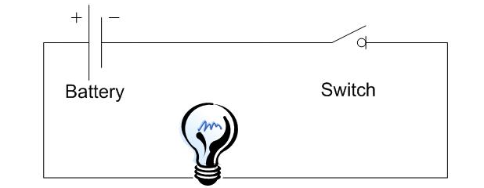

- A negative electric potential difference can be called a voltage drop

- A positive electric potential difference is called a voltage gain.
Electric Potential Difference ($V$) - the change in electric potential energy associated with charges at two different points in a circuit

Where $∆E$ is the change in energy ($J$) and
$Q$ is the amount of charge ($C$).

- The unit for electrical potential difference is the volt. (named after Count Alessandro Volta (1745 – 1827))

One volt $(V)$ is the electric potential difference between two points if one joule of work $(J)$ is required to move one coulomb $(C)$ of charge between the points.

Example 2 Jack walks across a carpeted floor and goes to open a door, he receives a static electric shock of 500 V which transfers 15 J of electrical energy between him and the door. What is the quantity of charge transferred in the spark?

Example 3 Calculate the electric potential difference between the negative and positive terminals of a battery if $1500 J$ of electric potential energy is transformed to move $125 C$ of charge between the terminals.

Questions # 1-6, 9
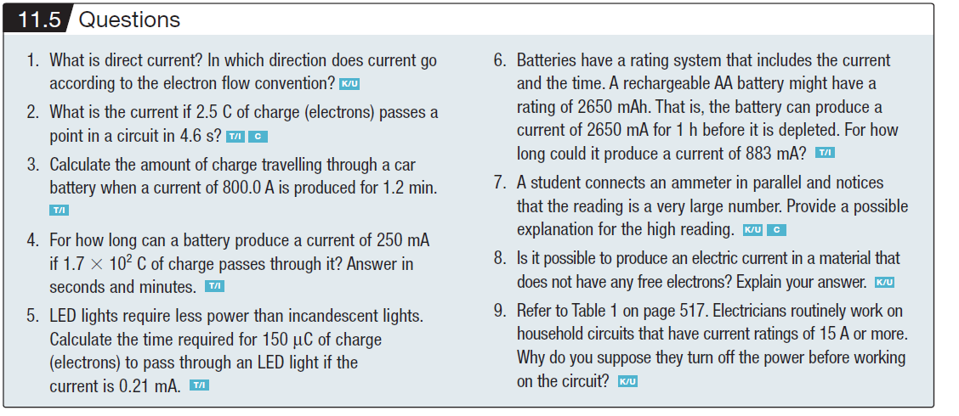

Questions #1-7
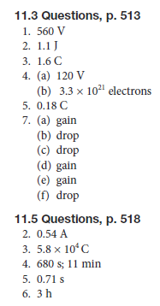
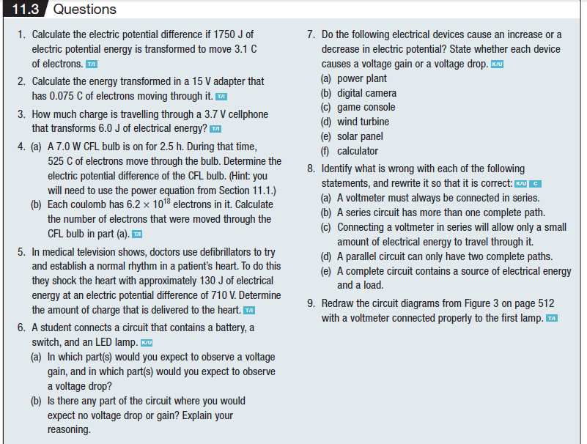

Homework: Read 16.2, 16.3, and learn the symbols in Fig 16.5
Pg. 575 #1-3, 9-14

