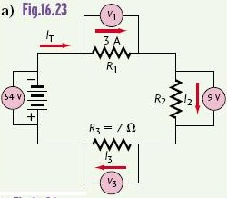
 | V[V] | I[A] | R[Ω]
1
2
3
T

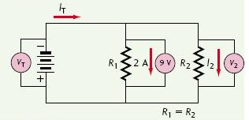
 | V[V] | I[A] | R[Ω]
1
2
T

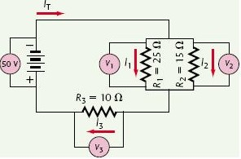
 | V[V] | I[A] | R[Ω]
1
2
3
T

 | V[V] | I[A] | R[Ω]
1
2
3
4
T
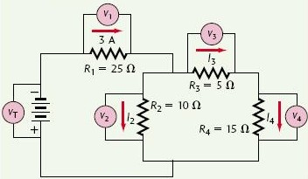

 | V[V] | I[A] | R[Ω]
1
2
3
4
5
6
T
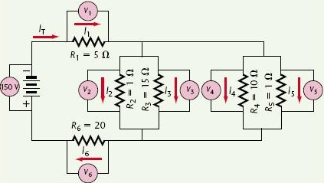

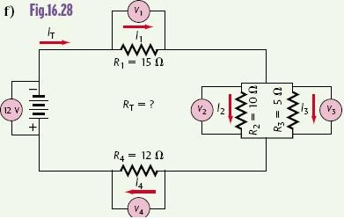
 | V[V] | I[A] | R[Ω]
1
2
3
4
T

