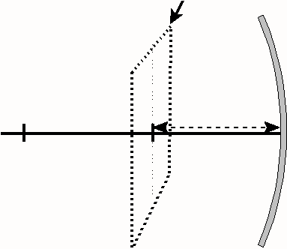
- Label the diagram of a Concave Mirror to the right.

- Complete each incomplete sentence and draw the characteristic ray it describes.

Concave Mirror Characteristic Rays
Parabolic Characteristics:
Any incident ray parallel to the principal axis will | 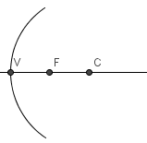
Any incident ray passing through the Focus will
Circular Characteristics:
Any incident ray striking the Vertex will
Any incident ray passing through the Centre of Curvature will

NOTE: Any ray originating on the object, and reflecting off the mirror, will pass through a corresponding point on the image. Characteristic rays simply help predict Image Characteristics.
- Complete the following ray diagrams and state the image characteristics.
Object Location | Images Formed by Concave Mirrors  Ray Diagrams | Image Characteristics
Beyond C | 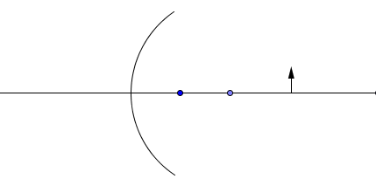 | Size  Inversion  Location  Type
At C | 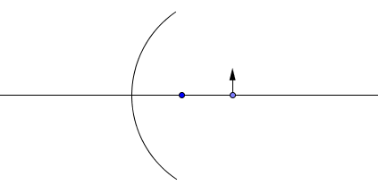 | Size  Inversion  Location  Type
Between  F and C | 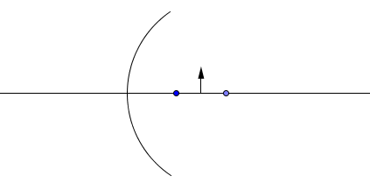 | Size  Inversion  Location  Type
At F | 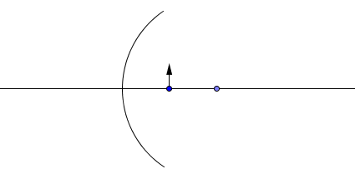 | Size  Inversion  Location  Type  Uses
Between F and V | 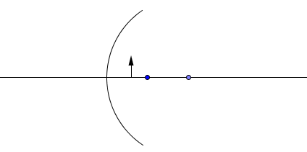 | Size  Inversion  Location  Type
FAR beyond  C | 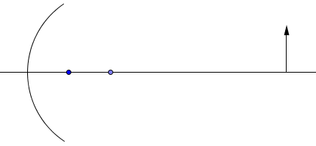 | Size  Inversion  Location  Type

- If the OBJECT IS MOVED far beyond the Centre of Curvature, the image will move

___________________________________________________________________.

- If the OBJECT IS MOVED close toward the focus, the image will move

____________________________________________________________________.

- In order to produce a VIRTUAL IMAGE with CONCAVE MIRROR, an object must be placed

____________________________________________________________________.

- In order to produce a REAL IMAGE with CONCAVE MIRROR, an object must be placed

____________________________________________________________________.

- In order to produce an UPRIGHT IMAGE with CONCAVE MIRROR, an object must be placed

____________________________________________________________________.

- In order to produce the LARGEST IMAGE POSSIBLE with CONCAVE MIRROR, an object must

be placed ____________________________________________________________.

