Position Time Graphs

How can we describe the motion of each of the following graphs?

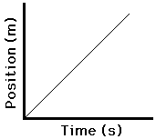 | 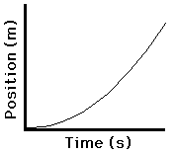 | 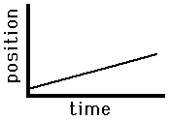
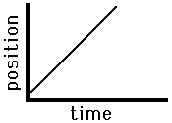 | 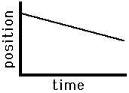 | 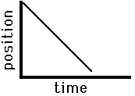
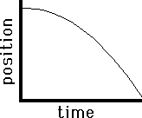 | 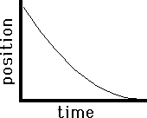

The Importance of Slope - the slope of the line on a position-time graph is equal to the velocity of the object.

Velocity-Time Graphs

Describe the motion of the following Velocity Time Graphs

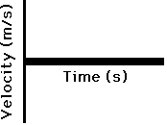
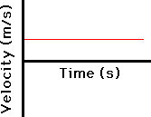

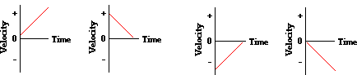

The Importance of Slope - the slope of the line is equal to the acceleration of the velocity-time

graph.
The Area Between the Velocity Line and the Axes
For velocity- time graphs, the area bound by the line and the axes represents the displacement.
The shaded area is representative of the displacement during from 0 seconds to 6 seconds. Calculate the displacement. | 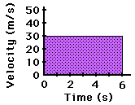
The shaded area is representative of the displacement during from 0 seconds to 4 seconds. Calculate the displacement. | 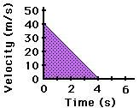
The shaded area is representative of the displacement during from 2 seconds to 5 seconds. This area takes on the shape of a trapezoid. Calculate the displacement during this time. | 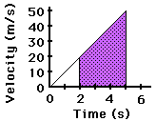

Let’s break down this graph to find the total displacement over 20 seconds:

Graph Conversion Practice

- For the provided $v$-$t$ graph, draw the corresponding $d$-$t$ and $a$-$t$ graphs.

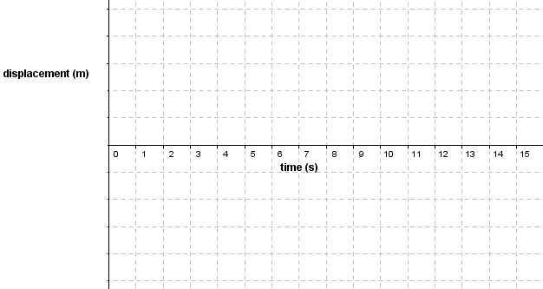

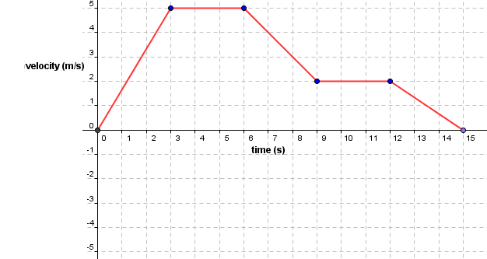
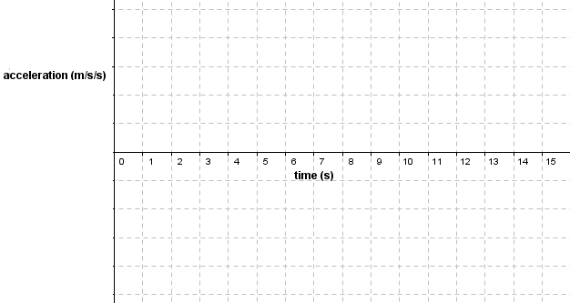
Graph Conversion Practice

- For the provided $v$-$t$ graph, draw the corresponding $d$-$t$ and $a$-$t$ graphs.

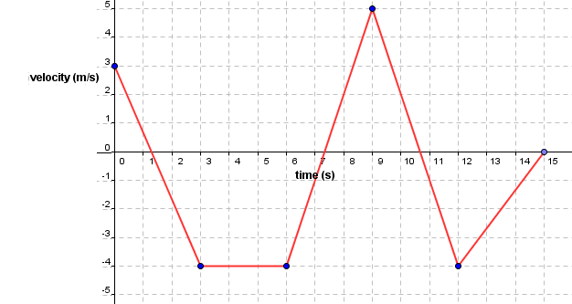
Answer the questions on this page using the graph below.
36
24
Velocity (m/s) [S]

12
0
-12
30
10
25
15
5
0
20
Time (s)

Questions
- What was the truck’s velocity at 5 s, 15 s, 25 s, 30 s?

- What was the displacement of the truck in the interval 0 to 5 s?

- What was the displacement of the truck in the interval 10 to 20 s?

- What was the displacement of the truck in the interval 25 to 30 s?

- What was the distance of the entire trip?

- What was the average speed for the whole trip?

- What was the displacement for the whole trip?

- What was the average velocity for the whole trip?

- In which interval was the acceleration the greatest?

- During which time intervals is the truck
- speeding up?
- slowing down?
- traveling South
- traveling North

Answers: (0) 6 m/s [S], 24 m/s [S], 0, 12 m/s [N], (1) 30 m[S], (2) 210 m[S], 3. 45 m [N], 4. 390 m, 5. 13 m/s, 6. 300 m [S], 10.0 m/s[S], 8. 20 – 27.5 s, 9. a) 5 - 10s, 10 - 15s, 25 – 27.5s , b) 20 - 25s , c) 0 – 25 s , d) 25 - 30 s

