S
I
L
T

- Draw the image using 2 rays.
Concave or Convex?
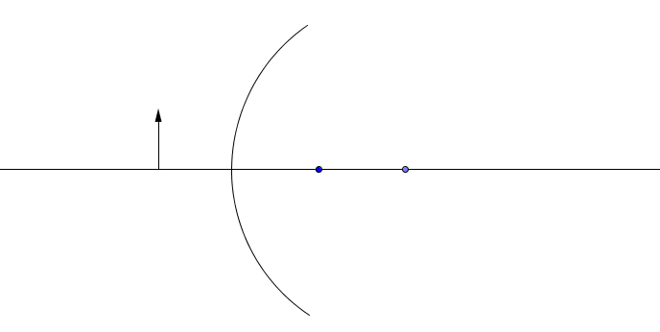

S
I
L
T
- Draw the image using 2 rays.

Concave or Convex?

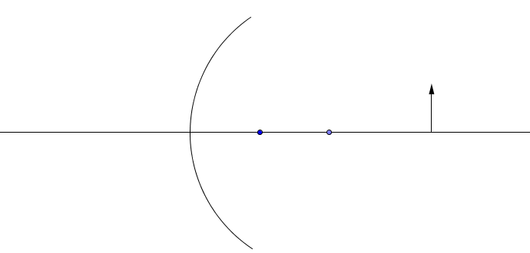

S
I
L
T
- Draw the image behind the mirror.

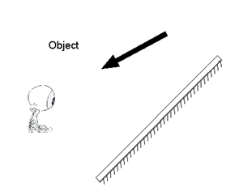

S
I
L
T

- Draw the image using 2 rays.

Concave or Convex?

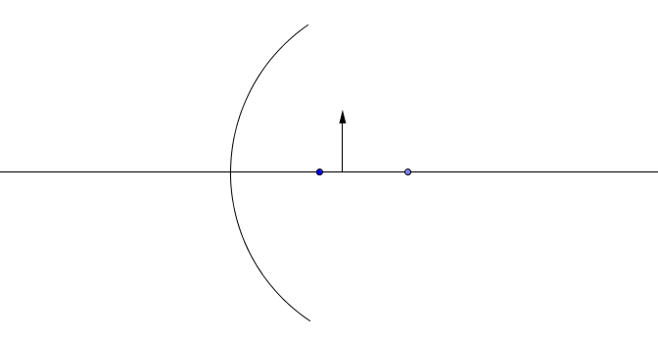

S
I
L
T
- Draw the image using 2 rays.

Concave or Convex?

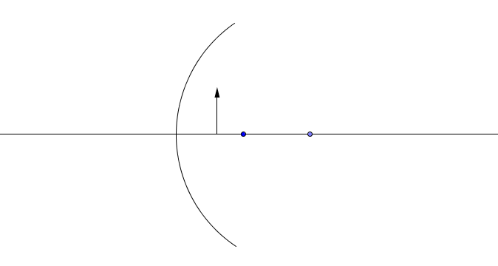

S
I
L
T

- Draw the image using 2 rays.

Concave or Convex?

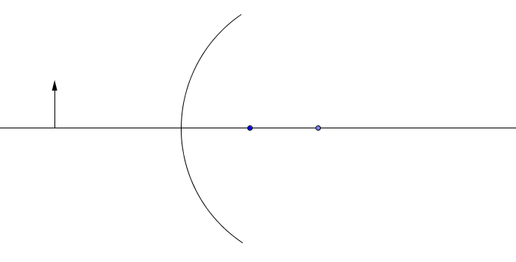

S
I
L
T
- Draw the ray diagram using three rays.

Concave or Convex?

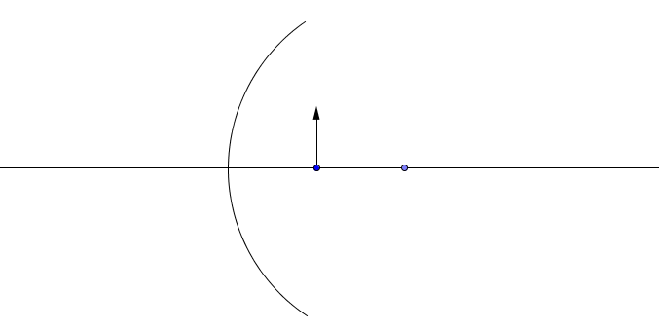

S
I
L
T

- Draw the image using 2 rays.

Concave or Convex?

