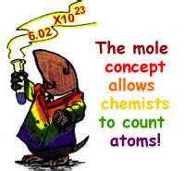The Mole – A Chemical Counting Unit

## Learning Goals:

I will be able to explain how the mole is used to count atoms, molecules and formula units.

I will be able to convert between moles and number of particles.

## The Mole – the Chemistry Counting Unit

* Atoms are ________________________ small so a lot of them take up very little space. Which makes them REALLY hard to count!
* Chemists use the **____________________** as the counting unit for atoms or molecules.
* A mole is 6.02 x 1023 “things”
  + Those “things” are _______________________ or _______________________________

## Avogadro’s Constant: 6.02 x 1023

* Named after Italian Amedeo Avogadro who determined the volume of one _____________________ of gas.
* This value is also equal to the number of particles in exactly 12g of _______________________ atoms.

## Converting between Moles and Number of Particles

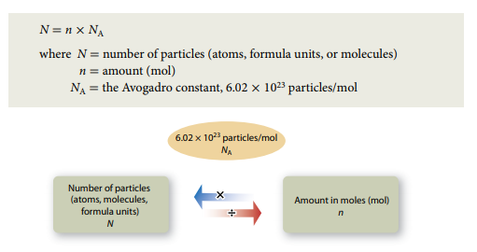

# Examples:

1. Converting Moles to Particles: 1.0 L of water contains 3.0 moles of water. How many molecules of water are in 1.0L?
2. Converting Particles to Moles: 1 tonne of iron contains 1.08 x 1025 atoms of iron. How many moles is this?

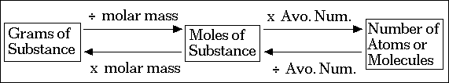

# Today’s Tasks:

1. Describe the similarities and differences between a “dozen” and a “mole”.
2. In your own words, define the following terms:
   1. The mole
   2. Avogadro’s Constant
3. How many moles of water does 3.12 x 1023 molecules represent?
4. Convert 3.01 x 1023 molecules of C2H6 to moles.
5. How many moles of glucose does 5.5 x 1025 molecules represent?
6. How many moles of CaCl2 does 2.41 x 1024 represent?
7. How many atoms does 2.6 moles of He represent?
8. How many molecules are in 0.25 moles of CH4?
9. A propane tank for a BBQ is designed to hold about 2.04 x 102 moles of propane. How many propane molecules are in the tank?
10. Intervenous (IV) drips often contain saline solution. If one litre of saline solution contains about 0.154 mol of sodium chloride, how many sodium chloride molecules are in that litre?
11. Laughing gas is a compound called dinitrogen monoxide. What amount in moles of N2Ocontain 3.40 x 1023 molecules?
12. Calcium phosphate, Ca3(PO4)2 is one of the main forms in which calcium is found in cow’s milk.
    1. How many calcium ions are in one molecule of calcium phosphate? (hint: look at the subscript)
    2. How many calcium ions are in 1 mol of calcium phosphate?
    3. How many calcium ions are in 0.519 mol of calcium phosphate?’



**If you need extra practice: Pg. 177 #1-4, 6 & Pg. 178 #5-6**