Inertia and Mass
Read from Lesson 1 of the Newton's Laws chapter at The Physics Classroom:

http://www.physicsclassroom.com/Class/newtlaws
MOP Connection: Newton's Laws: sublevel 1

- Inertia is

- The amount of inertia possessed by an object is dependent solely upon its __________.
- Two bricks are resting on edge of the lab table. Shirley Sheshort stands on her toes and spots the two bricks. She acquires an intense desire to know which of the two bricks are most massive. Since Shirley is vertically challenged, she is unable to reach high enough and lift the bricks; she can however reach high enough to give the bricks a push. Discuss how the process of pushing the bricks will allow Shirley to determine which of the two bricks is most massive. What difference will Shirley observe and how can this observation lead to the necessary conclusion?

- Would Shirley Sheshort be able to conduct this same study if she was on a spaceship in a location in space far from the influence of significant gravitational forces? _______ Explain your answer.

- If a moose were chasing you through the woods, its enormous mass would be very threatening. But if you zigzagged, then its great mass would be to your advantage. Explain why.

- Inertia can best be described as _____.
  - the force which keeps moving objects moving an stationary objects at rest.
  - the willingness of an object to eventually lose its motion
  - the force which causes all objects to stop
  - the tendency of any object to resist change and keep doing whatever its doing
- Mass and velocity values for a variety of objects are listed below. Rank the objects from smallest to
greatest inertia. _______ < _______ < _______ < _______
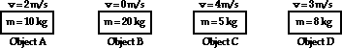

Pre-Conceptions
Students typically have many pre-conceived notions regarding concepts in Physics. It has always proven useful to bring these ideas to the forefront of your mind and to make an effort to evaluate their correctness. The following statements pertain in one way or another to common notions regarding central concepts of this unit. Identify each statement as being either true (T) or false (F).

Force and Motion - What Do You Believe?
The following statements pertain in one way or another to common notions regarding force and motion. Identify each statement as being either true (T) or false (F).

T or F? Statement
1. A force is required to keep an object moving in a given direction.
2. An upward moving object must be experiencing (or at least usually does experience) an upward force.
3. A rightward moving object must be experiencing (or at least usually does experience) a rightward force.
4. A ball is thrown into the air and is moving upwards and rightwards towards its peak.
The ball experiences a force which is directed upwards and rightwards.
5. If a person throws a ball with his hand, then the force of the hand upon the ball is experienced by the ball for at least a little while after the ball leaves the hand.
6. A cannonball is shot from a cannon at a very high speed. The force of the explosion will be experienced by the cannonball for several seconds (or a least a little while).
7. If an object is at rest, then there are no forces acting upon the object.

Mass and Weight - What Do You Believe?
The following statements pertain in one way or another to common notions regarding mass and weight. Identify each statement as being either true (T) or false (F).

T or F? Statement
1. Objects do NOT weigh anything when placed in a vacuum.
2. All objects weigh the same amount when placed in a vacuum, regardless of their mass.
3. An object weighs less on the moon than it does on the Earth.
4. The mass of an object on the moon is the same as its mass on the Earth.
5. A high-speed object (say, moving at 200 mi/hr) will weigh less than the same object when at rest.
6. A high-speed object (say, moving at 200 mi/hr) will possess measurably more mass than the same object when at rest.
7. Weight is measured in pounds; mass is measured in Newtons.
8. A free-falling object still has weight.
9. Weight is the result of air pressure exerted upon an object.

Balanced vs. Unbalanced Forces
Read from Lesson 1 of the Newton's Laws chapter at The Physics Classroom:

http://www.physicsclassroom.com/Class/newtlaws
MOP Connection: Newton's Laws: sublevels 2 and 3

Review: An object at rest. An object in motion Unless acted upon
- The amount of force required to keep a 6-kg object moving with a constant velocity of 2 m/s is __ N.
a. 0.333
b. 2
c. 3
d. 6
e. 12
f. ... nonsense! A force is NOT required to keep an object in motion.

- Renatta Oyle is having car troubles. She is notorious for the trail of oil drops which she leaves on the streets of Glenview. Observe the following oil traces and indicate whether Rennatta's car is being acted upon by an unbalanced force. Give a reason for your answers.

 | Unbalanced Force?
a.  Reason: | Yes | or | No
b.  Reason: | Yes | or | No
c.  Reason: | Yes | or | No

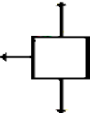
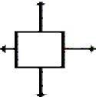
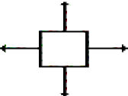
- Each one of the dot diagrams in question #2 can be matched to a force diagram below. The force diagrams depict the individual forces acting upon the car by a vector arrow. The arrow direction represents the direction of the force. The arrow length represents the strength of the force. Match the dot diagrams from #2 to a force diagram; not every force diagram needs to be matched.

Dot Diagram(s):
_______ Dot Diagram(s):
_______ Dot Diagram(s):
_______

- If the net force acting upon an object is 0 N, then the object MUST ___.
  - be moving b. be accelerating c. be at rest
d. be moving with a constant speed in the same direction e. either c or d.

- These graphs describe the motion of Carson Busses at various times during his trip to school. Indicate whether Carson's vehicle is being acted upon by an unbalanced force. Give a reason in terms of a description of what the car is doing (speeding up, slowing down, or constant velocity).

 | 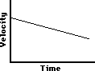 | 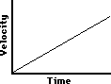
Unbalanced Force?  Yes or No?  Reason/Description: | Unbalanced Force?  Yes or No?  Reason/Description: | Unbalanced Force?  Yes or No?  Reason/Description:
- A free-body diagrams show all the individual forces acting upon an object. The net force is the
vector sum of all these forces (∑F). Determine the net force and state if there is an acceleration.

a.

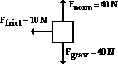
∑F = Accel'n? Yes or No
b.

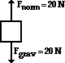
∑F = Accel'n? Yes or No
c.

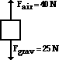
∑F = Accel'n? Yes or No

- During an in-class discussion, Anna Litical suggests to her lab partner that the dot diagram for the motion of the object in #6b could be
Anna's partner objects, arguing that the object in #6b could not have any horizontal motion if there are only vertical forces acting upon it. Who is right? ________ __ Explain.

- During an in-class discussion, Aaron Agin asserts that the object in #6a must be moving to the left since the only horizontal force acting upon it is a "left-ward" force. Is he right? ______ Explain.

- The diagrams below depict the magnitude and direction of the individual forces acting upon an object. Which objects could be moving to the right? Circle all that apply.
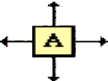
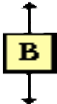
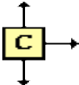
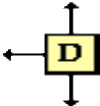
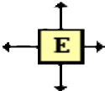

Net Force Help Sheet
Understanding the influence of individual forces upon the acceleration of objects demands familiarity with the variety of types of forces. Quickly internalize the following.

Type of Force | Explanation
Weight (W) or  Force of Gravity (Fgrav) | The force of gravity is the force at which the earth, moon, or other massively large object attracts another object towards itself. By definition, this is the weight of the object. All objects upon earth experience a force of gravity which is directed "downward" towards the center of the earth. The force of gravity on earth is always equal to the weight of the object as found by the equation:  Fgrav = m * g where g = 9.8 N/kg (on Earth)
Normal Force (Fnorm or FN) | The normal force is the support force exerted upon an object which is in contact with another stable object. For example, if a book is resting upon a surface, then the surface is exerting an upward force upon the book in order to support the weight of the book. On occasions, a normal force is exerted horizontally between two objects which are in contact with each other.
Spring (Fspring or Fs) | The spring force is exerted by a spring upon the objects connected to each of its two ends. Spring forces may result from either a compressed or a stretched spring. The magnitude of a spring force is dependent upon the elasticity of the spring (usually denoted by its spring constant k) and upon the amount of compression or stretch (x) of the spring from its equilibrium position. The general equation for spring force is  Fspring = k * x
Sliding Friction Forces (Ffrict or Ff) | The frictional force is the force exerted by a surface as an object moves across it. The sliding friction force opposes the motion of the object. For example, if a book moves across the surface of a desk, then the desk exerts a frictional force in the opposite direction of its motion. The frictional force can often be calculated using the equation:  Ffrict = µ * F_{N}orm
Air Resistance (Fair or R) | The air resistance is a special type of frictional force which acts upon objects as they travel through the air. The force of air resistance always opposes the motion of the object. This force will frequently be neglected due to its negligible magnitude. It is most noticeable for objects which travel at high speeds (e.g., a skydiver or a downhill skier) or for objects with large surface areas.
Tension (Ftens or T) | The tension is the force which is transmitted through a string, rope, wire or cable when it is pulled tight by forces acting from each end. The tensional force is directed along the wire and pulls equally on the objects on either end of the wire.
Applied Force (Fapp or Fa) | The applied force is the force which is applied to an object by a person or another object. If a person is pushing a desk across a room, then there is an applied force acting upon the object. The applied force is the force exerted on the desk by the person.

The Net Force
The net force is the vector sum of all the individual forces acting upon an object. In other words, Fnet = F1 + F2 + F3 + ... where F1, F2, and F3 represent the various forces acting upon an object. Like any force, the net force is a vector and has a direction. Being the vector sum of all the forces, there may be some negative signs present in the net force equation to indicate that one force is opposite in direction to another force. According to Newton's second law, the net force is related to mass and acceleration

Fnet = ∑F = m * a

Other Noteworthy Items:
- Scales are devices which are equipped with springs that are compressed or stretched when objects are placed upon the scales. These springs allow the scales to measure the magnitude of other forces (i.e., normal forces, tensional forces, gravitational forces, etc.) acting upon the object.
- Pulleys are objects which change the direction of a force but not its magnitude.

Problem-Solving Strategy:
To solve problems involving several forces acting upon a single object:
- Sketch a free-body diagram (FBD). To simplify the diagram, represent the object by a "box". Draw arrows representing all the forces acting on the object. The direction of each arrow should indicate the direction of the force.
- Label each arrow on the FBD with a symbol to indicate the type of force it is. Use the table above to help you label the forces appropriately.
- Write down all given information in variable form (e.g., m = 2.0 kg; a = 1.5 m//s, right). Write down the desired end - what the problem asks to be determined or calculated (e.g., find Fapp).
- The net force is the vector sum of all the individual forces acting on the object. The "summing" of individual forces is simplified if the horizontal and vertical forces are summed separately. Indicate this in the form of equations based upon the FBD.
Horizontal ∑Fx = Fright - Fleft (assumes that rightward is the + direction) Vertical ∑Fy = Fup - Fdown (assumes that up is the + direction)
- Write the net force equations (∑Fx = m * ax and ∑Fy = m * ay).
- Solve the problem for the desired information by relating the #4 and the #5 equations.
Perhaps the most difficult (and most critical) principle of mechanics is the principle of net force and acceleration. You will probably be tempted to approach Fnet problems in a memorization mode. Avoid such an approach; nothing could lead you into a state of frustration more readily. Rather, internalize the meaning of the various forces, learn to recognize their presence by careful analysis of a problem, and base your problem-solving strategies on an understanding of such concepts and upon the application of good logic and reasoning. Approach Fnet problems in logic mode.

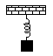

Recognizing Forces

Read from Lesson 2 of the Newton's Laws chapter at The Physics Classroom:

http://www.physicsclassroom.com/Class/newtlaws

MOP Connection: Newton's Laws: sublevel 4

There are several situations described below. For each situation, fill in the list provided by indicating which forces are present and stating which features of the situation you used to determine the presence or absence of the force. To facilitate this exercise, utilize the Net Force Help Sheet. Upon completion of this assignment, check your answers using the available Web page.

http://www.physicsclassroom.com/morehelp/recforce/recforce.html

Description of Situation | Force Present (P) or Absent (A)? |  |  |  | Explanation
 | Gravity | P | or | A?
 | Spring: | P | or | A?
 | Tension | P | or | A?
 | Normal: | P | or | A?
1. A block hangs at rest
from the ceiling by a  piece of rope. Consider | Friction | P | or | A?
the forces acting on the
block. | Air Res.: | P | or | A?
 | Gravity | P | or | A?
 | Spring: | P | or | A?
 | Tension | P | or | A?
2. A block hangs from the | Normal: | P | or | A?
ceiling by a spring.
Consider the forces  acting on the block when | Friction | P | or | A?
it is at rest (at its  equilibrium position). | Air Res.: | P | or | A?

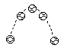
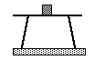

Description of Situation | Force Present (P) or Absent (A)? |  |  |  | Explanation
 | Gravity | P | or | A?
 | Spring: | P | or | A?
 | Tension | P | or | A?
3. A ball is shot into the air | Normal: | P | or | A?
with a spring-loaded  cannon. Consider the | Friction | P | or | A?
forces acting on the ball
while it is in the air. | Air Res.: | P | or | A?
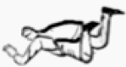 | Gravity | P | or | A?
 | Spring: | P | or | A?
 | Tension | P | or | A?
4. A skydiver (who hasn't opened his parachute | Normal: | P | or | A?
yet) falls at terminal  velocity. Consider the | Friction | P | or | A?
forces acting on the
skydiver. | Air Res.: | P | or | A?
 | Gravity | P | or | A?
 | Spring: | P | or | A?
 | Tension | P | or | A?
5. A block rests on top of a | Normal: | P | or | A?
table. Consider only the
forces acting upon the | Friction | P | or | A?
block.
 | Air Res.: | P | or | A?

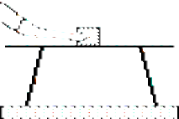
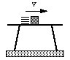

Description of Situation | Force Present (P) or Absent (A)? |  |  |  | Explanation
 | Gravity | P | or | A?
 | Spring: | P | or | A?
 | Tension | P | or | A?
6. A block is being pushed | Normal: | P | or | A?
across the top of a table.
Consider only the forces  acting upon the block. | Friction | P | or | A?
 | Air Res.: | P | or | A?
 | Gravity | P | or | A?
 | Spring: | P | or | A?
 | Tension | P | or | A?
 | Normal: | P | or | A?
7. A block slides across the
top of a table. Consider  only the forces acting | Friction | P | or | A?
upon the block.
 | Air Res.: | P | or | A?
 | Gravity | P | or | A?
 | Spring: | P | or | A?
8. The driver of a car has her foot on the gas pedal. | Tension | P | or | A?
The wheels are turning as
the car accelerates down  the road. Consider only | Normal: | P | or | A?
the forces acting upon
the car. | Friction | P | or | A?
 | Air Res.: | P | or | A?

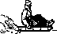

Description of Situation | Force Present (P) or Absent (A)? |  |  |  | Explanation
 | Gravity | P | or | A?
 | Spring: | P | or | A?
 | Tension | P | or | A?
9. A person is sitting on a
sled and gliding across  loosely-packed snow | Normal: | P | or | A?
along a horizontal
surface. Consider only | Friction | P | or | A?
the forces acting on the
person. | Air Res.: | P | or | A?
 | Gravity | P | or | A?
 | Spring: | P | or | A?
10. The wheels of a car are locked as it skids to a | Tension | P | or | A?
stop while moving across
a level highway.  Consider only the forces | Normal: | P | or | A?
acting on the car.
 | Friction | P | or | A?
 | Air Res.: | P | or | A?
 | Gravity | P | or | A?
 | Spring: | P | or | A?
 | Tension | P | or | A?
11. A bucket of water, attached by a rope, is | Normal: | P | or | A?
being pulled out of a
well. Consider only the | Friction | P | or | A?
forces acting on the
bucket. | Air Res.: | P | or | A?

Mass and Weight
Read from Lesson 2 of the Newton's Laws chapter at The Physics Classroom: http://www.physicsclassroom.com/Class/newtlaws/
MOP Connection: Newton's Laws: sublevel 6
- The standard metric unit for mass is _____ and the standard metric unit for weight is _____.
- An object's mass refers to _____ and an object's weight refers to _____. Fill in each blank.
  - the amount of space it takes up b. the force of gravitational attraction to Earth
c. how dense an object is d. the amount of stuff present in the object
- Complete the following table showing the relationship between mass and weight.

Object | Mass | Approx. Weight
Melon | 1 kg
Apple |  | ~1.0 N
Pat Eatladee | 25 kg

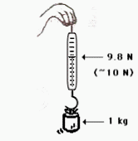
- Different masses are hung on a spring scale calibrated in Newtons. The force exerted by gravity on 1 kg = ~10 N.
The force exerted by gravity on 5 kg = ~______ N. The force exerted by gravity on 70 kg = ~________ N.
- The value of g in the British system is 32 ft/sec2. The unit of force is pounds. The unit of mass is the slug. Use your weight in pounds to calculate your mass in units of slugs. PSYW

- You might be wondering about your metric weight. Using conversion
factors, convert your weight in pounds to units of N. (Use 1 N = 0.22 pounds) PSYW

- What is the mass and weight of a 10-kg object on earth?
Mass = Weight =
What is the mass and weight of a 10-kg object on the moon where the force of gravity is 1/6-th that of the Earth's?
Mass = Weight =
- Conclusion: The _______________ of an object is independent of the object's location in space.

Newton's Second Law of Motion
http://www.physicsclassroom.com/Class/newtlaws/
MOP Connection: Newton's Laws: sublevel 7

- The acceleration of an object is ______________ ____ related to the net force exerted upon it and
_______ ____ ____ related to the mass of the object. In equation form: a = Fnet / m.
  - directly, inversely b. inversely, directly c. directly, directly d. inversely, inversely
- Use Newton's second law to predict the effect of an alteration in mass or net force upon the acceleration of an object.
  - An object is accelerating at a rate of 8 m/s2 when it suddenly has the net force exerted upon increased by a factor of 2. The new acceleration will be _________ m/s2.
  - An object is accelerating at a rate of 8 m/s2 when it suddenly has the net force exerted upon increased by a factor of 4. The new acceleration will be _________ m/s2.
  - An object is accelerating at a rate of 8 m/s2 when it suddenly has the net force exerted upon decreased by a factor of 2. The new acceleration will be _________ m/s2.
  - An object is accelerating at a rate of 8 m/s2 when it suddenly has its mass increased by a factor of 2. The new acceleration will be _________ m/s2.
  - An object is accelerating at a rate of 8 m/s2 when it suddenly has its mass decreased by a factor of 4. The new acceleration will be _________ m/s2.
  - An object is accelerating at a rate of 8 m/s2 when it suddenly has the net force exerted upon increased by a factor of 2 and its mass decreased by a factor of 4. The new acceleration will be
_______ m/s2.
  - An object is accelerating at a rate of 8 m/s2 when it suddenly has the net force exerted upon increased by a factor of 4 and its mass increased by a factor of 2. The new acceleration will be
_______ m/s2.
  - An object is accelerating at a rate of 8 m/s2 when it suddenly has the net force exerted upon increased by a factor of 3 and its mass decreased by a factor of 4. The new acceleration will be
_______ m/s2.
- These force diagrams depict the magnitudes and directions of the forces acting upon four objects. In each case, the down force is the force of gravity. Rank these objects in order of their acceleration,

from largest to smallest:
_______ > _______ >
_______ > _______

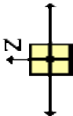
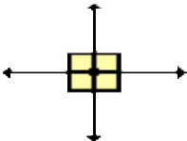
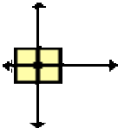
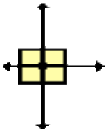

Net Force and Acceleration
http://www.physicsclassroom.com/Class/newtlaws/:
MOP Connection: Newton's Laws: sublevels 3 (front), 8 and 9 (back)

- Luke Autbeloe drops a 5.0 kg fat cat (weight = ~50.0 N) off the high dive into the pool below (which on this occasion is filled with water). Upon encountering the water in the pool, the cat encounters a 50.0 N upward restraining force. Which one of the velocity-time graph best describes the motion of the cat? Accompany your answer with a description of the cat's motion.

A B C
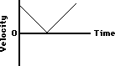
Description of cat's motion while falling through air: Description of cat's motion after hitting the water:
- Which one of the following dot diagrams best describes the motion of the falling cat from the time that they are dropped to the time that they hit the ground? _The arrows on the diagram represent the point at which the cat hit the water. Support your answer with sound reasoning:

3 Several of Luke's friends were watching the motion of the falling cat. Being "physics types", they began discussing the motion and made the following comments. Indicate whether each of the comments are correct or incorrect? Support your answers.

Student Statement:
Correct? Yes or No

a. Once the cat hit the pool, the forces are balanced and the cat will stop.
Reason:
b. Upon hitting the pool, the cat will accelerate upwards because the pool applies an upward force.
Reason:
c. Upon hitting the pool, the cat will bounce upwards due to the upwards force. Reason:

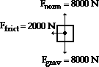
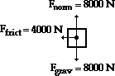
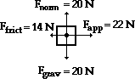
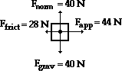

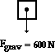
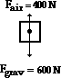
  - For each force diagram, determine the net or resultant force (∑F), the mass and the acceleration of the object. Identify the direction (the second blank) of the two vector quantities. NOTE: Fgrav stands for the weight of the object.

a. | b.
∑F = , | ∑F = ,
m = | m =
a = , | a = ,
c. | d.
∑F = , | ∑F = ,
m = | m =
a = , | a = ,
e. | f.
∑F = , | ∑F = ,
m = | m =
a = , | a = ,

Free-Body Diagrams
http://www.physicsclassroom.com/Class/newtlaws/
MOP Connection: Newton's Laws: sublevel 5
Construct free-body diagrams for the following physical situations. Label all forces (e.g, Fgrav, Fnorm, Fapp, Ffrict, Fair, Ftens, etc. ).

    - A physics book rests upon a level table.
    - A skydiver is falling and has reached a terminal velocity.
    - A large crate is being pushed leftward at a constant velocity.

    - A sledder has reached the bottom of a hill and is coasting rightward while slowing down.
    - A ball is moving upwards towards its peak. Ignore air resistance.
    - An air track glider moves rightward at constant speed.

    - The brakes are applied to a rightward moving car and it skids to a stop.
    - A spider is slowly descending a thin silk thread at constant speed.
    - A projectile is moving upwards and rightwards towards the peak of its trajectory.

    - An elevator is rising at a constant velocity; it is not touching the elevator shaft.
    - An upward rising elevator is slowing down; it is not touching the elevator shaft.
    - A force is applied to accelerate a crate across a rough horizontal surface.

Newton's Second Law
http://www.physicsclassroom.com/Class/newtlaws/
MOP Connection: Newton's Laws: sublevels 8 and 9
Free-body diagrams are shown for a variety of physical situations. Use Newton's second law of motion (∑F=m•a) to fill in all blanks. Use the approximation that g = ~10 m/s/s.

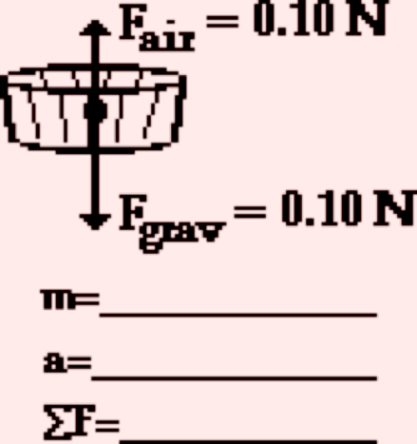
      - b.

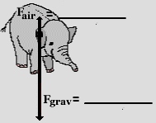

m=10000 kg
a = 8.0 m/s/s, down
F = ________
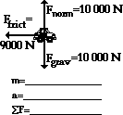
d. e.
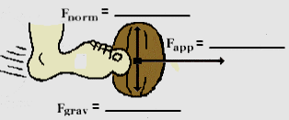

m=0.500 kg
a = ___________
F = 124 N, right
c.

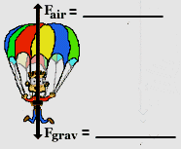

m=800 kg
a = 6.0 m/s/s, up
F = ________

f.

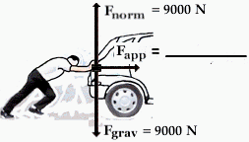

m= _________
a = 1.50 m/s/s, right
F = ____________

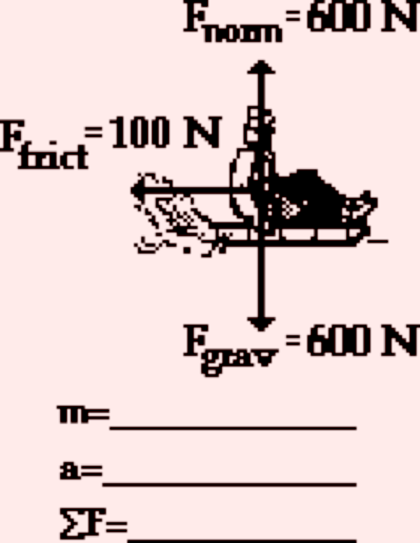
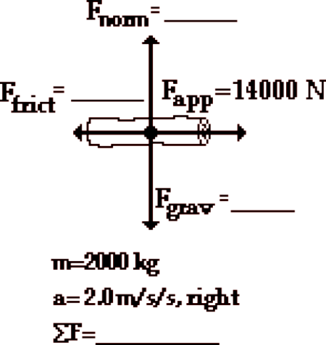
g. h. i.
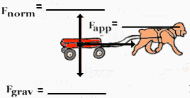

m=15.0 kg
a = 0.50 m/s/s, right
F = ____________

Drawing Free Body Diagrams

http://www.physicsclassroom.com/Class/newtlaws/
MOP Connection: Newton's Laws: sublevels 5, 8 and 9

For the following situations, draw a free-body diagram in which you represent the various forces which are acting upon the object(s) using vector arrows. Label each arrow to indicate the type of force.
Determine the magnitude of all forces and fill in the blanks.

- A 1.0 kg book is at rest on a table top. Diagram the forces acting on the book.

FBD:
∑Fx = ∑Fy =

ax = ay =

- A 5.0 kg flying squirrel is flying from a tree to the ground at constant velocity. Consider air resistance. Diagram the forces acting on the squirrel.

FBD:
∑Fx = ∑Fy =

ax = ay =

- An egg with a weight of 0.10 N is free-falling from a nest in a tree. Neglect air resistance. Diagram the forces acting on the egg as it is falling.

FBD:
∑Fx = ∑Fy =

ax = ay =

- A 2.0-kg bucket is tied to a rope and accelerated upward out of a well at a rate of 1.5 m/s/s. Neglect air resistance. Diagram the forces acting on the bucket.

FBD:
∑Fx = ∑Fy =

ax = ay =

- A 2.0-N force is applied to a 1.0 kg book in order to move it across a desk with an acceleration of 0.5 m/sec2. Consider frictional forces. Neglect air resistance. Diagram the forces acting on the book.

FBD:
∑Fx = ∑Fy =

ax = ay =

- A 1.5-N force is applied to a 1.0 kg book in order to move it across a desk at constant velocity. Consider frictional forces. Neglect air resistance. Diagram the forces acting on the book.

FBD:
∑Fx = ∑Fy =

ax = ay =

- A 70.0-kg skydiver is descending with a constant velocity. Consider air resistance. Diagram the forces acting upon the skydiver.

FBD:

∑Fx = ∑Fy =

ax = ay =

- A 30-N force is applied to drag a 20-kg sled across loosely-packed snow with an acceleration of 1.0 m/s2. Diagram the forces acting upon the sled.

FBD:
∑Fx = ∑Fy =

ax = ay =

- An 800-kg car is coasting to the right with a leftward acceleration of 1 m/s2. Diagram the forces acting upon the car.

FBD:
∑Fx = ∑Fy =

ax = ay =

Friction

http://www.physicsclassroom.com/Class/newtlaws/
- A classroom desk supported by long legs is stationary in the room. A teacher comes around and pushes upon the desk in an effort to start it into a state of motion. The desk does not budge. The desk remains at rest because ______.
  - there is a force of static friction opposing its motion
  - there is a force of kinetic or sliding friction opposing its motion
  - there is a force of rolling friction opposing its motion
  - there are small dust mites at the desk's feet which push back on the desk to keep it at rest
- A classroom desk supported by long legs is stationary in the room. A teacher comes around and pushes upon the desk in an effort to start it into a state of motion. The desk is finally accelerated from rest and then moves at a constant speed of 0.5 m/s. The desk maintains this constant speed because ______.
  - there is a force of static friction balancing the teacher's forward push
  - there is a force of kinetic or sliding friction balancing the teacher's forward push
  - there is a force of rolling friction balancing the teacher's forward push
  - the teacher must have stopped pushing
- The symbol µ stands for the _____
  - coefficient of friction b. force of friction c. normal force
- The units on µ are _____
  - Newton b. kg c. m/s/s d. ... nonsense! There are no units on µ.
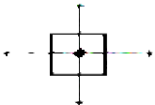
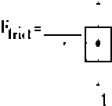
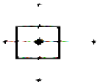
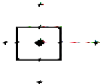
- Use the friction equation and Fnet = m•a to fill in the blanks in the following situations.

Air Resistance and Terminal Velocity
http://www.physicsclassroom.com/Class/newtlaws/
MOP Connection: Newton's Laws: sublevel 11
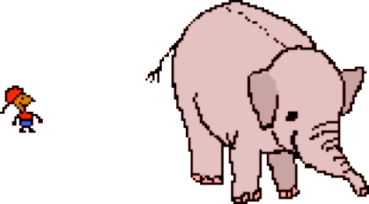
- When falling under the influence of air resistance and dropped from the same height, which will fall to the ground at a faster rate?
  - a mouse b. an elephant c. the same
- Which of the following variables will have a direct effect upon the amount of air resistance experienced by an object? (That is, for which of these quantities will an increase lead to a resulting increase in the air resistance force?)
  - speed b. air density c. cross-sectional area
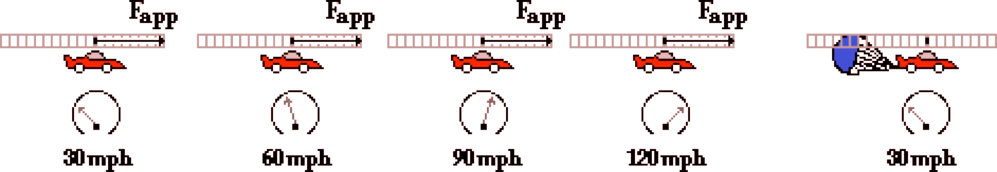
- Consider the dragster's motion below. Speedometer readings and the forward propulsion force (Fapp) are shown. The top (or terminal) speed is 120 mph. Draw Fair force arrows on each diagram to illustrate how the amount of air resistance changes during the course of its motion.
- Draw Fair force arrows to show how the force of air resistance changes on the falling skydiver. At
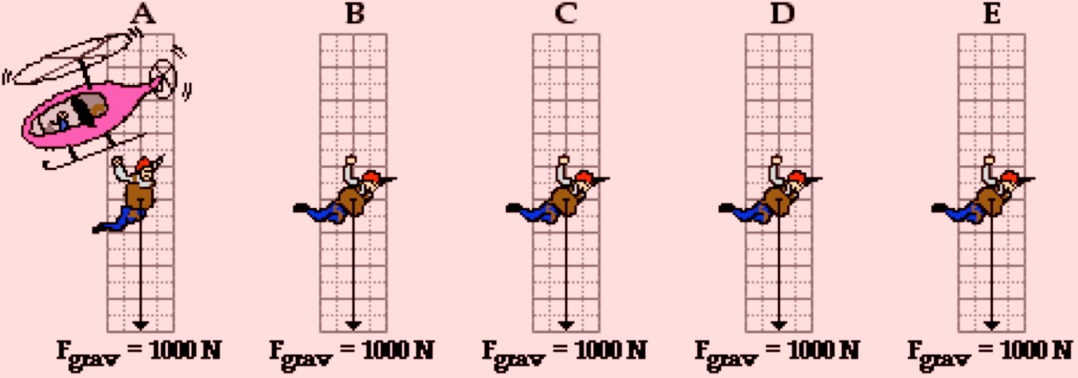
A, the diver has just jumped; and at E, the diver has just reached terminal velocity.
- Fill in the blanks in the following paragraph.
As an object moves faster and faster, the amount of air resistance _______________ _ (increases, decreases) until a state of terminal velocity is reached. Once terminal velocity is reached, the force of air resistance is ________________ (greater than, less than, equal to) the force of gravity. Hence, the object will ____________ ___ ____ ____ ____ __ (continue to accelerate, stop its motion, stop its acceleration, move back up to its starting position).

Skydiving
http://www.physicsclassroom.com/Class/newtlaws/
MOP Connection: Newton's Laws: sublevel 11
A 90-kg (approx.) skydiver jumps out of a helicopter at 6000 feet above the ground. As he descends, the force of air resistance acting upon him continually changes. The free-body diagrams below represent the strength and direction of the two forces acting upon the skydiver at six positions during his fall. For each diagram, apply Newton’s second law (Fnet = m•a) to determine the acceleration value.
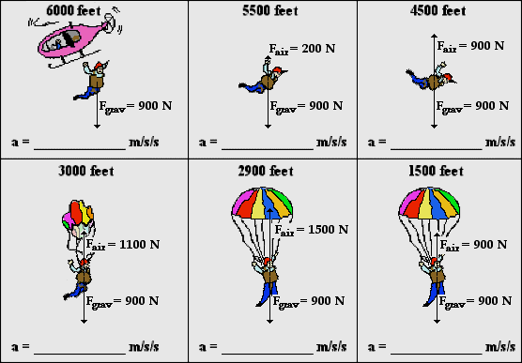
- At which two altitudes has the skydiver reached terminal velocity?
- At which altitude(s) is the skydiver in the state of speeding up?
- At which altitude(s) is the skydiver in the state of slowing down?
- At 2900 feet, the skydiver is ___________. Choose two.
  - moving upward b. moving downward c. speeding up d. slowing down
- Explain why air resistance increases from 6000 feet to 4500 feet.

- Explain why air resistance decreases from 3000 feet to 1500 feet.

The Elephant and the Feather
Study the two animations from the Multimedia Physics Studios
http://www.physicsclassroom.com/Class/newtlaws/
MOP Connection: Newton's Laws: sublevels 10 and 11

Without Air Resistance
Suppose that an elephant and a feather are dropped off a very tall building from the same height at the same time. Suppose also that air resistance could be eliminated such that neither the elephant nor the feather would experience any air drag during the course of their fall. Which object - the elephant or the feather - will hit the ground first? Many people are surprised by the fact that in the absence of air resistance, the elephant and the feather strike the ground at the same time. Why is this so? Test your understanding by identifying the following statements as being either True (T) or False (F).
1. The elephant and the feather each have the same force of gravity.
2. The elephant has more mass, yet they both experience the same force of gravity.
3. The elephant experiences a greater force of gravity, yet both the elephant and the feather have the same mass.
4. On earth, all objects (whether an elephant or a feather) have the same force of gravity.
5. The elephant weighs more than the feather, yet they each have the same mass.
6. The elephant clearly has more mass than the feather, yet they each weigh the same.
7. The elephant clearly has more mass than the feather, yet the amount of gravity (force) is the same for each.
8. The elephant has the greater acceleration, yet the amount of gravity is the same for each.

With Air Resistance
Now consider the realistic situation that both feather and elephant encounter air resistance. Which object - the elephant or the feather - will hit the ground first? Most people are not surprised by the fact that the elephant strikes the ground before the feather. But why does the elephant fall faster? Test your understanding by identifying the following statements as being either True (T) or False (F).
1. The elephant encounters a smaller force of air resistance and therefore falls faster.
2. The elephant has the greater acceleration of gravity and therefore falls faster.
3. Both elephant and feather have the same force of gravity, yet the acceleration of gravity is greatest for the elephant.
4. Both elephant and feather have the same force of gravity, yet the feather experiences a greater air resistance.
5. Each object experiences the same amount of air resistance, yet the elephant experiences the greatest force of gravity.
6. Each object experiences the same amount of air resistance, yet the feather experiences the greatest force of gravity.
7. The feather weighs more, and therefore will not accelerate as rapidly as the elephant.
8. Both elephant and feather weigh the same amount, yet the greater mass of the feather leads to a smaller acceleration.
9. The elephant experiences less air resistance and reaches a larger terminal velocity.
10. The feather experiences more air resistance and thus reaches a smaller terminal velocity.
11. The elephant and the feather encounter the same amount of air resistance, yet the elephant has a greater terminal velocity.

Newton's Third Law
http://www.physicsclassroom.com/Class/newtlaws/
MOP Connection: Newton's Laws: sublevel 12
A force is a push or pull resulting from an interaction between two objects. Whenever there is a force, there are two objects involved - with both objects pushing (or pulling) on each other in opposite directions. While the direction of the pushes (or pulls) are opposite, the strength or magnitudes are equal.
This is sometimes stated as Newton's Third Law of motion: for every action, there is an equal and opposite reaction. A force is a push or a pull and it always results from an interaction between two objects. These forces always come in pairs.

- For each stated action force, identify the reaction force.
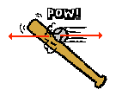
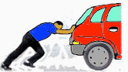
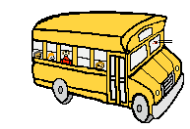
Bat hits ball. Man pushes car. Bus hits bug.

- Identify by words the action-reaction force pairs in each of the following diagrams.

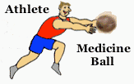 | 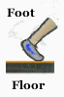 | 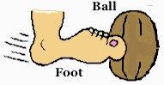

- TRUE or FALSE:
As you sit in your seat in the physics classroom, the Earth pulls down upon your body with a gravitational force; the reaction force is the chair pushing upwards on your body with an equal magnitude.
If False, correct the answer.

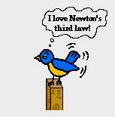
- Shirley Bored sits in her seat in the English classroom. The Earth pulls down on Shirley's body with a gravitational force of 600 N. Describe the reaction force of the force of gravity acting upon Shirley.

- Use Newton's third law (law of action-reaction) and Newton's second law (law of acceleration: a = Fnet/m) to complete the following statements by filling in the blanks.
  - A bullet is loaded in a rifle and the trigger is pulled. The force experienced by the bullet is
_______ ___ (less than, equal to, greater than) the force experienced by the rifle. The resulting acceleration of the bullet is ____________ (less than, equal to, greater than) the resulting acceleration of the rifle.

  - A bug crashes into a high speed bus. The force experienced by the bug is ____________ (less than, equal to, greater than) the force experienced by the bus. The resulting acceleration of the bug is ____________ (less than, equal to, greater than) the resulting acceleration of the bus.

  - A massive linebacker collides with a smaller halfback at midfield. The force experienced by the linebacker is ____________ (less than, equal to, greater than) the force experienced by the halfback. The resulting acceleration of the linebacker is __________ (less than, equal to, greater than) the resulting acceleration of the halfback.

  - The 10-ball collides with the 14-ball on the billiards table (assume equal mass balls). The force experienced by the 10-ball is ____________ (less than, equal to, greater than) the force experienced by the 14-ball. The resulting acceleration of the 10-ball is ____________ (less than, equal to, greater than) the resulting acceleration of the 14-ball.

Newton's Second Law Problem-Solving

http://www.physicsclassroom.com/Class/newtlaws/

For the following problems, construct a free-body diagram and show your work clearly.
- A rightward force of 302 N is applied to a 28.6-kg crate to accelerate it across the floor. The coefficient of friction between the crate and the floor is 0.750. Determine the acceleration of the crate.

- During a football workout, two lineman are pushing the coach on the sled. The combined mass of the sled and the coach is 300 kg. The coefficient of friction between the sled and the grass is 0.800. The sled accelerates at a rate of 0.580 m/s/s. Determine the force applied to the sled by the lineman.

- A 405-N rightward force is use to drag a large box across the floor with a constant velocity of 0.678 m/s. The coefficient of friction between the box and the floor is 0.795. Determine the mass of the box.

- A 6.58 x 103 N upward tension force is exerted on a 521-kg downward-moving freight elevator. Determine the acceleration of the elevator.

- A basketball star exerts a force of 3225 N (average value) upon the gym floor in order to accelerate his 76.5-kg body upward. (a) Determine the acceleration of the player. (b) Determine the final speed of the player if the force endures for a time of 0.150 seconds.

- At the end of the Giant Drop free fall ride, riders experience a large upward normal force to bring their falling bodies to a stop. Determine the normal force value required to accelerate a 52.1-kg physics student with an upward acceleration of 27.4 m/s/s.

- A hockey player accelerates a puck (m = 0.167 kg) from rest to a velocity of 50 m/s in 0.0121 sec. Determine the acceleration of the puck and the force applied by the hockey stick to the puck. Neglect friction.

- A falling skydiver is accelerating in the downward direction at 3.29 m/s/s. The mass of the skydiver (including parachute gear) is 67.2 kg. Determine the air resistance force on the skydiver (and accompanying parachute).

- A 67.2-kg falling skydiver opens his parachute and instantly slows down at a rate of 7.2 m/s/s. Determine the air resistance force on the skydiver (and accompanying parachute).

