NEWTONS LAWS

State which of Newton’s laws applies to each of the following situations, then explain the situation in terms of Newton’s law(s).

**1.** A plane flies overhead.

**2.** A rocket accelerates in space.

**3.** A car brakes to a sudden stop.

**4.** Someone throws a ball against a wall.

**5.** Two wrestlers are having a match.

**6.** A big rock is harder to throw than a small rock.

**7.** Your big brother can throw a ball farther than you can.

NEWTONS 2ND LAW

Solve for the missing variable. When one variable increases or decreases, what happens to the other two variables?

**1.** *m* = 30 kg, *a* = 5.0 m/s2, *F* = ?

**2.** *m =* 30 kg, *a =* 10 m/s2*, F = ?*

**3.** *F* = 15 N, *a* = 10 m/s2, *m* = ?

**4.** *F* = 30 N, *a* = 10 m/s2, *m* = ?

**5.** *F =* 10 N, *m* = 5 kg, *a* = ?

**6.** *F =* 10 N, *m* = 2.5 kg, *a* = ?

FREE BODY DIAGRAMS

Draw FBDs for each of the following situations.

**1.** A book rests on a desk.

**2.** A car drives along the road.

**3.** You push a refrigerator.

**4.** A train engine pulls three cars and a caboose. (5 diagrams)

NEWTONS 2ND LAW

Draw FBDs for the following situations. What is the *F*net in each case?

**1.** A 100 g bird sits in its nest.

**2.** A 5000 kg airplane flies at a constant speed of 400 km/h.

**3.** A 1.0 kg ball initially at rest rolls down a plane inclined at 35°.

**4.** Two people are pushing a heavy box in the same direction. Person A applies a force of 30 N [L15°D], while person B applies a force of 35 N [R20°D].

GRAVITY

**1.** Define the following terms: gravity, mass, weight. What are the units of each?

**2.** What is your mass on Earth? What is your mass on the Moon? on Mars?

**3.** What is your weight on Earth? What is your weight on the Moon? on Mars?

**4.** Under what circumstances would you experience weightlessness?

NEWTONS LAW OF GRAVITATION

**1.** Calculate the gravitational attraction between you and a 60 kg person 1.0 m away from you.

**2.** What happens to the gravitational attraction between you if you each move 1.0 m away from your original positions?

**3.** What is your weight on Earth’s surface?

**4.** What is your weight at 4 times the distance from Earth’s surface?

FRICTION

**1.** Microscopic view of two surfaces meeting

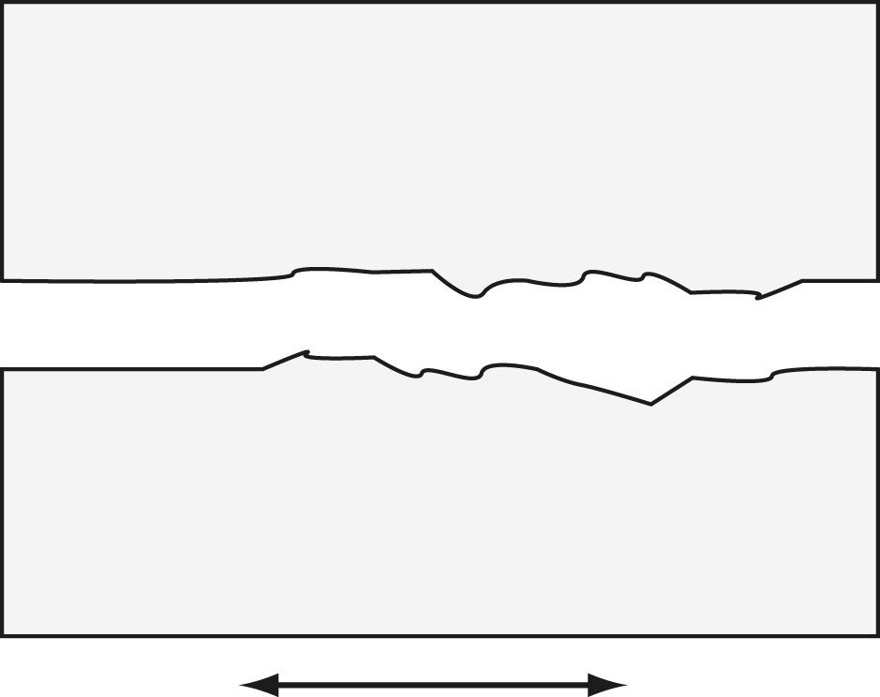

As the two surfaces move relative to each other, the microscopic bumps grind on each other, causing a resistance to motion.

Points of Discussion

**1.** Does speed make a difference?

**2.** Why is it harder to get something sliding than to keep it sliding?

**3.** How does oil work to “lubricate” a connection to make the sliding easier?

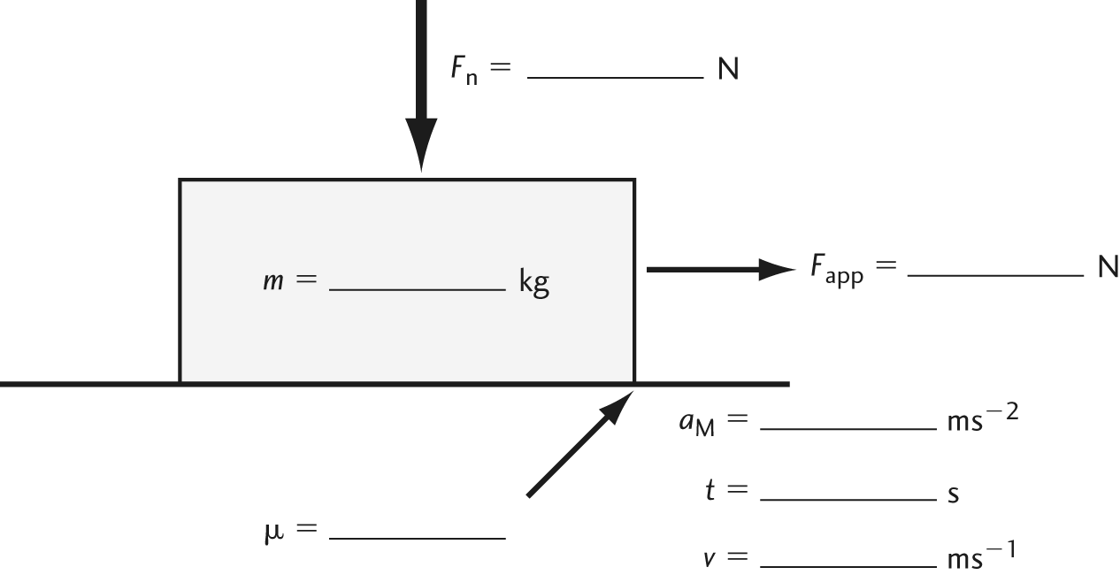

MOMENTUM

Before

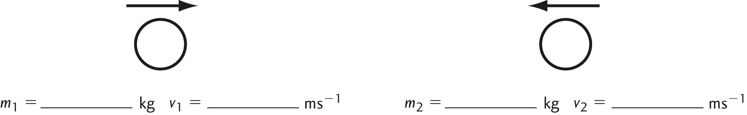

After

IP-After

Assume objects are NOT rotating.

**1.** Locate the center of mass of the system before and after the collision.

**2.** Compute the unknowns using the given parameters and proper problem solving technique.

**3.** Aside from momentum, what other parameter must be conserved? Using the values that you computed earlier, did this occur? What type of collision is this?