**Pages 261-367**

|  |
| --- |
| ***Something to Think About See page 261***    Until recently, most Canadians .., |

|  |
| --- |
| ***GETTING STARTED* *See page 26***  Look at the photograph .., |

**4.1 Water: Essential for Life**

Read pages 268-274 and **Summarize**

*Read - DID YOU KNOW?*

See ***Section 4.1 Questions*** –*see page* 274

Questions: # 1-6

**4.2 What’s in Clean Water?**

Read pages 275-279 and **Summarize**

*Read - DID YOU KNOW?*

See ***Section 4.2 Questions*** –*see page* 279

Questions: # 1-9

**4.2 What’s in Clean Water?**

Read pages 275-279 and **Summarize**

*Read - DID YOU KNOW?*

See ***Section 4.2 Questions*** –*see page* 279

Questions: # 1-9

**4.3 What’s in Polluted Water?**

Read pages 280-284 and **Summarize**

*Read - DID YOU KNOW?*

See ***Sample Problem – Determining the Safety of Water – page 283***

***TEACHER Discussion and City of Brantford Water Quality***

See ***Section 4.3 Questions*** –*see page* 284

Questions: # 1-6

**4.6 *Case Study***

***Protecting Canada’ Great Lakes Environment***

Read pages 290-292 and **Summarize**

*Read - DID YOU KNOW?*

***TEACHER Discussion***

**4.7 Acids and Bases**

*Something to Think About* ***See page 293***

Much of what we know …,

**Dissociating** of NaCl results in NaCl **(s)** → Na **+2** **(aq)** + Cl **–** **(aq)**

See Table 1 on page 293

**The Arrhenius Theory of Acids and Bases**

* When *hydrogen chloride* dissolves in water, for example, it dissociates (breaks apart) into hydrogen ions and chloride ions

HCl(aq) → H+(aq) + Cl-(aq)

* When *sodium hydroxide* dissolves in water, for example, it dissociates (breaks apart) into sodium ions and hydroxide ions

NaOH(aq) → Na+(aq) + OH-(aq)

* In the late 18th century, Arrhenius published a theory to explain the nature of acids and bases.

***The Arrhenius theory of acids and bases***

An acid is a substance that dissociates in water to produce one or more hydrogen ions, H+

A base is a substance that dissociates in water to form one or more hydroxide ions, OH-

NOTE: the absence of water from the above equations

**According to the Arrhenius theory**;

* **Acids** increase the concentration of ***H+***in aqueous solutions, thus, an Arrhenius acid must contain hydrogen as the source of *H+*
* **Bases**, on the other hand, increase the concentration of **OH-** in aqueous solutions, thus, an Arrhenius base must contain the hydroxyl group, ─OH, as the source of OH-
* Arrhenius believed that although water acts as a solvent, it does not participate in the reaction that produces the ions.
* Scientists now believe that water does react with the ions in solution.
* The process in which ions are formed from electrically neutral molecules (or atoms) is called **ionization.**

***What happens if you put H2O into the equation?***

HCl(aq) + H2O(l) → H+(aq) + Cl-(aq) + H2O(l)

* Noticed that the water is unchanged when the reaction is represented this way.
* Earlier Lesson: water is a polar molecule, the O atom has a partial negative charge, and the H atoms have a partial positive charge, thus H2O must interact in some way with the ion H+ and Cl- .
* Chemists discovered that protons do not exist in isolation in aqueous solution (the hydrogen ion is simply a proton, it is a positively charged nuclear particle)
* Instead, protons are always *hydrated*: they are attached to water molecules.
* A hydrated proton is called a ***hydronium ion, H3O+ (aq)***
* Hydronium ion is a hydrogen ion covalently bonded to a water molecule.
* NOTE: H2O can be written as H + and OH -

Ionization equation: HCl(aq) + H2O(l) → H3O+(aq) + Cl-(aq)

* To simplify the ionization equation, we remove the water molecule from both sides of the equation;

Ionization equation: HCl(aq) + H2O(l) → H3O+(aq) + Cl-(aq)

* The result is the equation below;

Simplifies ionization equation: HCl(aq) → H+(aq) + Cl-(aq)

See ***Sample Problem 1****– pages 295*

*Writing Dissociation and Ionization Equations*

Strong and Weak Acids

**Strong Acid**

* **Strong acid** is an acid that completely ionizes in water to form ions and, therefore, is a good conductor of electricity.
* Acids that dissociates completely in water.
* All the molecules of HCl in an aqueous solution **dissociate** into H+ and Cl- ions.

HCl(aq) → H+(aq) + Cl-(aq)

100% 100% 100%

* The H+ ions, bond with surrounding water molecules to form **hydronium ions, H3O+**
* Therefore, *the concentration of hydronium ions in a dilute solution of a strong acid is equal to the concentration of the acid*

**HCl(g)**+ H2O(l) → **H3O+(aq)** + Cl-(aq)

**Weak Acid**

* **Weak acid** is an acid that partially ionizes in water to form ions and, therefore, is a poor conductor of electricity.
* Weak acids dissociates very slightly in a water solution.
* Thus, only a small percentage of the acid molecules break apart into ions.
* Most of the acid molecule remains intact.
* Only 1% of the acetic acid molecules dissociate at any given moment.
* Therefore, *the concentration of hydronium ions in a solution of a weak acid is always less than the concentration of the dissolved acid*

CH3COOH(aq) + H2O(l) ↔ H3O+(aq) + CH3COO-(aq)

**NOTE**: *Reversible Arrow;* this indicates,the products of the reaction also react to produce the original reactants

* See Table 2 on page 296
* Most acids are weak acids – when you see a reversible chemical equation involving an acid, you can safely assume that the acid is weak.

**There are three types of acids;**

**Monoprotic acids:** contain only one hydrogen ion that can dissociate

Ex., **H**Cl(aq) → **H+**(aq) + Cl-(aq)

**Diprotic acids:** contain two hydrogen ions that can dissociate

Ex., H2SO4(aq) → H+(aq) + HSO4-(aq)

HSO4-(aq) ↔ H+(aq) + SO4-2(aq)

**Triprotic acids:** contain three hydrogen ions that can dissociate

Ex., **H3PO4**(aq) ↔ **H+**(aq) + H­2PO4-(aq)

H2PO4-(aq) ↔**H+** (aq) + HPO4-2(aq)

HPO4-2(aq) ↔**H+**(aq) + PO4-3(aq)

**Strong Base**

* Dissociates completely into ions in water.
* All oxides and hydroxides of alkali metals.
* *The concentration of hydroxide ions in dilute solutions of a strong base equals the concentration of the base*

**Weak Base**

* Dissociates very slightly in a water solution.

NH3(aq) + H2O(l) ↔ NH4+(aq) + OH-(aq)

Concentration and Strength

* Recall **dilute** and **concentrated solutions.**
* See Figure 5 & 6 on page 297
* The concentration of a solution can be expressed in several ways.
* For consumers, acetic acid or vinegar can be expresses as a %.
  + Ex., 5% solution of acetic acid, which means that 5mL of pure acetic acid is dissolved in every 100 mL of a vinegar solution.
  + In chemistry, the concentration of a solution is often expressed as a molar concentration.
  + The molar concentration (M) is the amount, in moles, of solute dissolved in 1L of solution (mol/L).
  + Ex., Nitric acid (HNO3 (aq)) M=15.4 mol/L.
  + In the environmental industry, often very low detection limits are needed.
  + Concentrations may be measured as mg/L, or parts per million (ppm).
  + Ex., public swimming pool has chlorine levels around 1 ppm to inhibit bacterial growth.

Hydrogen Ion and Hydroxide Concentrations

* The properties of acids are determined by the hydrogen ions that are present in solution.
* The higher the concentration of hydrogen ions, the more acidic the solution is.

*How can you determine the molar concentration of hydrogen ion in an acid solution?*

* Recall that strong acids and strong bases completely undergo 100% ionization.

Ex., HCl(g) → H+(aq)  + Cl-(aq)

Initial 1 mol 0 mol 0 mol

Final 0 **1** mol **1** mol

***LEARNING TIP***

***Concentration,* [ ]**

**[ ] around an ion or molecule indicates the molar concentration of the substance.**

* In this solution, the solution, the concentration of hydrogen ions, [H+(aq)], and the concentration of chloride ions, [Cl -(aq)], are 1.0 mol/L because one mole of HCl (aq) ionizes into one mole of H+(aq)  and one mole of Cl-.
* The same properties for strong acids apply for strong bases.
* As a result, the reaction of strong NaOH (aq) would result in 100% complete ionization.

Ex., NaOH(aq) → Na+(aq) + OH-(aq)

Initial 2 mol 0 mol 0 mol

Final 0 **?**  mol **?** mol

See ***Sample Problem 2****– pages 298*

*Calculating Concentrations of Hydrogen and Hydroxide Ions*

Try ***Practice – see page 300***

***# 1-4***

* After many experiments on acids and bases, chemists realized that acidic solutions contain hydrogen ions and hydroxide ions, but more hydrogen ions than hydroxide ions.
* After testing pure water, chemists have noticed the following result;
* All aqueous solutions contain ions.
* The following chemical equation represents the dissociation of water molecules;

H2O(l) + H2O(l) ↔ H3O+(aq) + OH-(aq)

H2O(l) ↔ H3O+(aq) + OH-(aq)

* Through experimentation, chemists have shown:
* The concentration of hydronium ions in neutral water at 250C, is only 1.0x10-7 mol/L.
* The concentration of hydroxide ions in neutral water at 250C, is only 1.0x10-7 mol/L.
* [H3O+] = [OH-] = 1.0x10-7 mol/L

pH

*Something to Think About* ***See page 301***

The extremely wide range of hydrogen …,

The **pH** of a solution is defined as the negative of the exponent to the base 10 of the hydrogen ion concentration.

*WHAT???*

* Using pH, the wide range of hydrogen ion concentrations can be expressed as a simple set of positive numbers, as shown below.

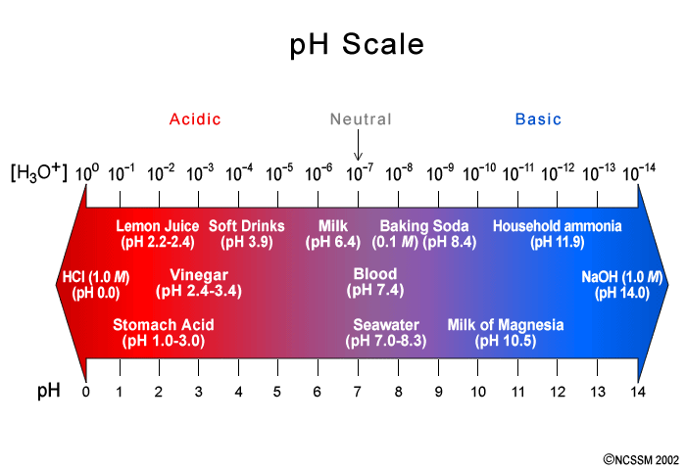

**Acidic solutions Neutral solutions Basic solutions**

[H3O+] > [OH-] [H3O+] = [OH-] [H3O+] < [OH-]

[H3O+] 1 → 1x10 -6 1x10 -7 [H3O+] 1x10 -8 → 1x10 -14

**pH = 0 → 6 pH = 7 pH = 8 → 14**

* You MUST use the following equations to solve for pH and molar concentration of the hydronium ion.

**pH= -log [H3O+]**

* If molar concentration is given, calculate the pH value using the above equation.
* Neutral water has concentration of **1.0 x 10 -7 mol/L**

Find the **pH value**?

pH= -log (1.0x10 -7)

= -(-7.00)

= 7.00

As a result, the pH of neutral water is **7.00**

* Ex., Ex.,

**[H3O+] = 10 –pH mol/L**

* If the pH is given, calculate the [H3O+] concentration using the above equation.

Ex., Acid solution, pH = 4 Find the [H3O+]?

Ex., Base solution, pH = 10 Find the [H3O+]?

**RULES on pH calculations;**

pH values range from 0-14

NO UNITS

For pH calculations: Minimal **ONE** Decimal place: Ex., pH = 7.**6**

For [H3O+] calculations: Minimal **ONE** Decimal place: Ex., 1.**5** x10 - 8

See ***Sample Problem 3-4*** *–* ***pages 302-303***

*Calculating the Hydrogen Ion Concentration from the pH*

Try ***Practice – see page 303***

*Questions* ***# 5-6***

See ***Section 4.7 Questions*** –*see page* 304

Questions: # 1-13

**4.8 *Explore an Issue***

***The Disposal of House Products***

Read pages 305-307 and **Summarize**

**4.11 Reactions of Acids and Bases**

*Something to Think About* ***See pages 316-318***

In your community, have you

Be familiar with the term, **neutralization**

*Read – LEARNING TIP*

*Read - DID YOU KNOW?*

Acid-Base Titration

* A **titration** is a common method of quantitative chemical analysis.
* It is used to determine the concentration of a substance in solution.
* A known volume of the sample to be analyzed is usually transferred into a flask.
* See figure 3 on page 318.
* The burette contains a solution of an accurately known concentration.
* This solution is called the **standard solution.**
* During the titration, the solution in the burette, called the **titrant,** is added drop by drop to the sample.
* The titrant is added until the reaction between the two chemicals is judged to be complete.
* To identify this point, an **indicator** is used.
* Below is a list of indicators and their associated pH colour.

[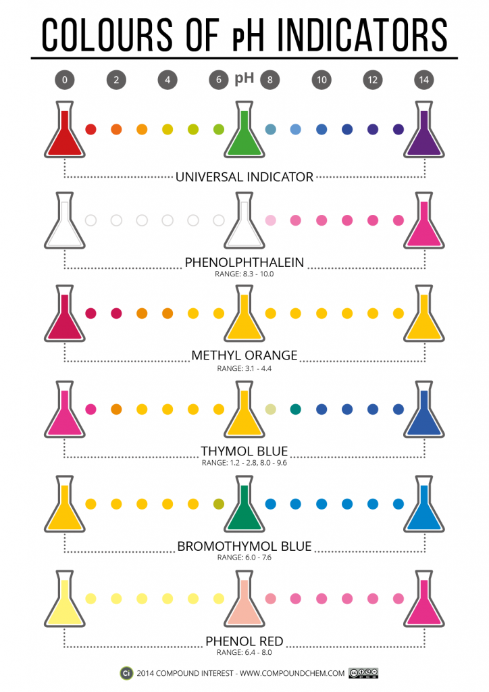](http://www.compoundchem.com/wp-content/uploads/2014/04/Colours-of-pH-Indicators-POST.png)

* The **endpoint** is reached when one drop of the titrant changes the colour of the indicator.
* At the endpoint, no more titrant is added and the volume that has been used is recorded.
* The mole ratio of reactants and products, from the balanced chemical equation, is then used to determine the concentration of the solution in the flask.
* At least three trials should be performed during a titration analysis to improve the reliability of the concentration calculated.
* The three trials are then averaged out.

See ***Sample Problem****–* ***pages 320-321***

*Quantitative Analysis Using Titration*

Try ***Practice – see page 22***

*Questions* ***# 4-8***

See ***Section 4.11 Questions*** –*see page* 323

Questions: # 1-7

**4.13 Acid Rain**

Read pages 325-329 and **Summarize**

***Read - DID YOU KNOW?***

See ***Section 4.13 Questions* –***see page* 329

**Questions:** # 1-7

**4.14 Gas Laws: *Why Gases Behave the Way They Do***

*Something to Think About* ***See pages 330-331***

Although you may live on the surface of Earth …,

## States of Matter

* There are three common states of matter: solid, liquid, and gas.

**Solids: -** Maintain their volume and shape.

- Forces of attraction between the entities in solids are quite strong.

- Strong attractive forces also keep the entities in solids close together.

- This helps to explain why solids are difficult to compress.

**Liquids: -** Liquids also maintain their volume.

* Unlike solids, liquids flow to take the shape of their container.
* Their ability to flow suggests that the forces of attraction in liquids are **not** as strong as in solids.
* Weaker attractive forces imply that the entities in a typical liquid are slightly farther apart than the entities in solids.
* The combination of weaker attractions and more space makes it easier for the entities to slide past each other as the liquid flows.
* This explains why liquids can flow and take the shape of their container.
* It also explains why liquids are slightly more compressible than solids.

**Gases: -** Take the shape and volume of their container.

* The attractive forces are very weak between entities in gases, and the distance between entities are great.
* This is why gases are the easiest of the three states to compress.

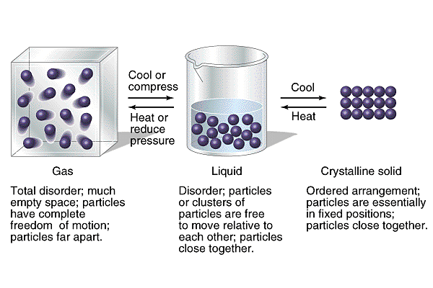

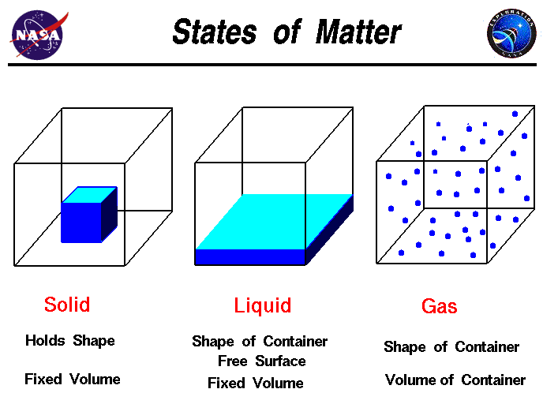

## Kinetic Molecular Theory

* 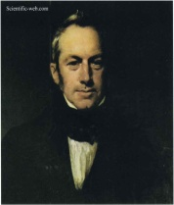**Robert Brown** [1773-1858] **(Brownian motion)** observed the random movement of microscopic particles suspended in a liquid or gas.

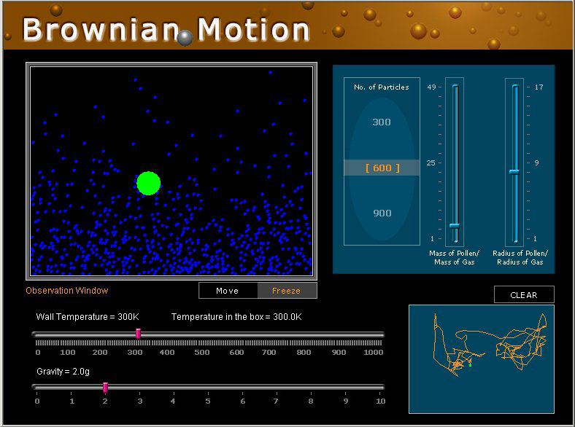

* Observations of Brownian motion led to development of the **kinetic molecular theory (KMT).**
* The main idea of the **kinetic molecular theory (KMT)** is that the entities in solids, liquids, and gases are in constant, random motion.
* As entities move about, they collide with one another and any other object in their path.
* The word “kinetic” comes from the Greek word *kinema,* meaning motion.
* The motion of these entities explains for example why you smell something cooking in the kitchen while studying **CHEMISTY** in the?
* **Kinetic energy** is the energy of an entity due to its motion.

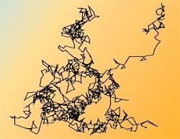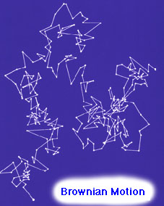

### How Entities Move

* There are three ways in which the entities in matter can move: **translational motion, rotational motion, and vibrational motion.**

|  |  |  |
| --- | --- | --- |
| **Vibrational Motion** | **Rotational Motion** | **Translational Motion** |
| * The back-and-forth vibrational of entities. * In gases, liquids, and solids. | * The spinning of an entity in place. * In gases and liquids. * Very limited in solids. | * The movement of an entity through space along a linear (straight-line) path. * In gases and liquids |

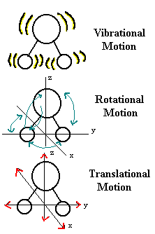

Types of Motion, Forces, and Organization of Entities in the Three States of Matter

|  |  |  |  |
| --- | --- | --- | --- |
|  | **SOLIDS** | **LIQUIDS** | **GASES** |
| **Types of Motion** | Vibrational | Vibrational, rotational, and translational | Vibrational, rotational, and translational |
| **Strength of Attraction** | Strongest | Intermediate | Weakest |
| **Organization of Entities** | Highly organized | Intermediate level of organization | Least organized |

### Kinetic Energy and Temperature

* **Temperature** is a measure of the average kinetic energy of the entities in a substance.
* 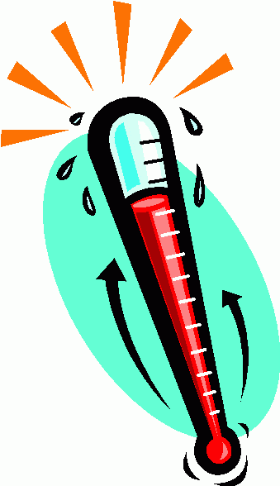When you measure the temperature of a substance with a thermometer, the entities of the substance collide with the glass of the thermometer.
* As the substance is warmed, these collisions become more energetic.
* This additional energy is then transferred to the liquid in the thermometer, causing the liquid to expand.

Gas Pressure

* **Pressure** is defined as the **force** exerted on an object per unit of surface **area**.
* Mathematically, pressure, P, is expressed as;
$$P=\frac{F}{A}$$

* **Force** (F) = N (Newton), **Area** (A) = m2
* The SI unit for pressure is the pascal (1 Pa = 1N/m2)
* Pressure is directly related to the size of force applied.
* Pressure is inversely related to the area.
* A large force applied to a small area will produce a large pressure.
* If the same force is applied to a large area, the pressure will be less.
* 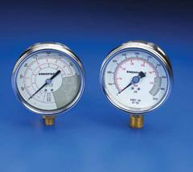Pressure is usually measured using regulators.

# Measuring Atmospheric Pressure

* **Atmospheric pressure** is the force per unit exerted by air on all objects.
* It is commonly reported in kilopascals, kPa
* At sea level, the pressure exerted by a column of air with a base on one square metre is equal to 101.325 kPa.
* This pressure is known as **standard pressure** and is basis for another unit of pressure: the atmosphere (atm).

**1 atm = 101.325 kPa**

* Traditionally, chemists defined the standard conditions for work with gases as the temperature 00C and pressure 101.325 kPa.
* A gas sample at these conditions is said to be at **standard temperature and pressure (STP).**

**STP = 101.325 kPa @ 00C**

* However, since 00C is not a convenient temperature at which to conduct laboratory investigations, scientists have recently defined another set of standard conditions.
* These conditions are called **standard ambient temperature and pressure (SATP).**
* **SATP** is defined as 250C and 100kPa.

**SATP = 100 kPa @ 250C**

* **Evangelista Torricelli** (1608-1674) was the first person to devise a method of measuring atmospheric pressure.
* Torricelli used mercury liquid (14 x’s greater density then water) and a glass tube along a dish to measure atmospheric pressure.
* Torricelli noticed that the mercury level in the tube changed slightly from day to day.
* The fluctuating mercury level was due to changes in air pressure.
* This device for measuring atmospheric pressure became known as a barometer.
* 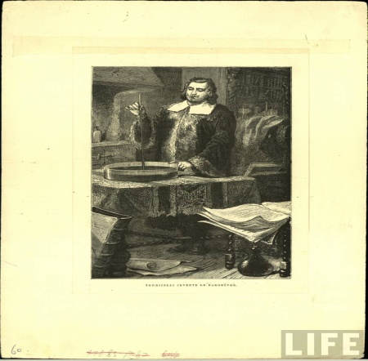At one time, the standard pressure was defined as 760 mm Hg or 760 Torr in honor of Torricelli.

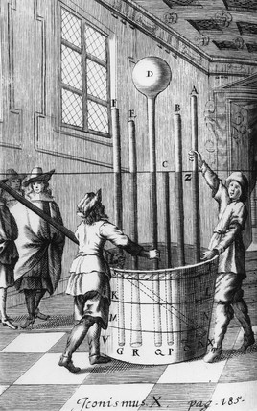

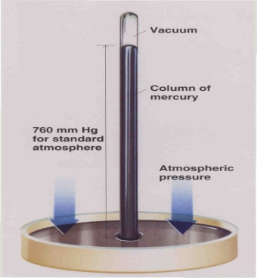

|  |  |  |
| --- | --- | --- |
| **Unit Name** | **Unit Symbol** | **Definition/Conversion** |
| millimetres mercury | mm Hg | 760 mm Hg |
| millimetres torr | mm torr | 760 mm torr |
| atmosphere | atm | 1 atm |
| Kilopascal | kPa | 101.3 kPa |
| ~~pounds per square inch~~ | ~~psi~~ | ~~1 psi = 6895 Pa~~  ~~[1kPa = 1000 kPa]~~ |

**760 mm Hg = 760 mm torr = 1 atm = 101.3 kPa**

Ex., **100.0 kPa = ______ mm torr** Ex., **725mmHg = ______ atm**

The Gas Laws – Absolute Temperature and Charles’ Law

# Absolute Zero and Temperature Scales

* How can a temperature have a negative value?
* 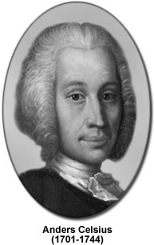The Celsius scale, developed by the Swedish scientist **Anders Celsius**  [1701-1744] in 1742, is convenient for most everyday situations.
* Celsius devised the scale by taking a thin, closed glass tube of a pure liquid, such as mercury, and recording the height of the liquid when the tube was placed in ice water.
* He called this height “100 degrees”.
* This process was repeated for boiling water, and this height “0 degrees”.
* 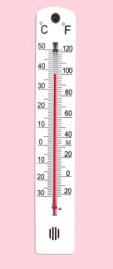Celsius then divided the distance between the marks evenly into 100 divisions.
* Each of these divisions is one degree Celsius.
* The scale was later reversed to make it a more practical unit of measure.
* The Celsius scale is also known as the centigrade scale.
* Centigrade simply means “divided into 100 degrees”.
* Later, another temperature scale was developed that proved to be more useful.
* Look at the following volume vs. temperature graph.
* We can extend the lines to left of the measured values to find the theoretical volume of gases as their temperatures decrease.
* The solid lines represent actual measurements.
* When the graphs of several volume-temperature experiments are extrapolate (dashed lines), all the lines meet at absolute zero, **-273.15 0C or 0 K.**

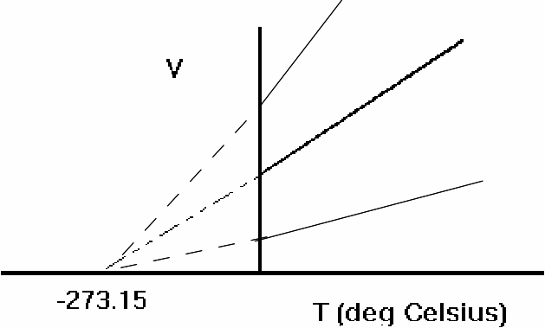

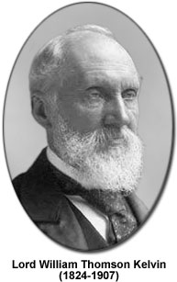

* **Lord Kelvin** [1824-1907] was the first scientists to notice this.
* He experimental with a variety of gases, graphing their volumes at various temperatures, and noticed that the graphs of all gases intercept the temperature axis at the same point.
* 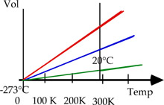This implied that the volume of every gas would become zero at a temperature of **-273.150C.**
* This temperature, at which a gas theoretically has no volume, is now known as **absolute zero**.
* It is the lowest possible temperature.
* Lord Kelvin developed a new temperature scale based on the value of -273.15 0C.
* He decided that the measurement would be equivalent to 0 on the new scale.
* By setting a value of zero for the lowest temperature that matter can achieve, Lord Kelvin ensured that the new scale would have no negative values.
* This is the scale that we now call the **Kelvin temperature scale** or **absolute zero** scale.
* It has the unit symbol “ **K** ”.
* In theory, at 0 K, entities should have no motion and therefore no kinetic energy.

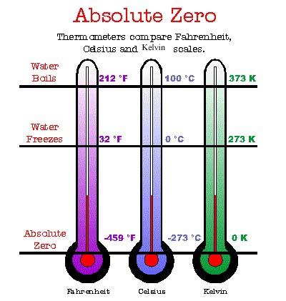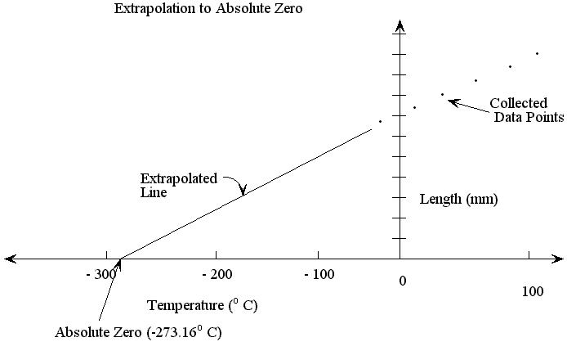

**To convert 0C into Kelvin; * Memorize**

**TK = 0C + 273**

**To convert Kelvin into 0C; * Memorize**

**0C = K - 273**

# Charles’ Law – The Relationship between Volume and Temperature

* 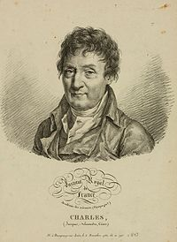An understanding of the relationship between the volume of gas and temperature has been attributed to French scientist **Jacques Charles** (1746-1823).
* Charles investigated the expansion of a variety of gases by placing a sample of gas in a closed, expandable container.
* Charles found that the volume of a gas increases as its temperature increases.
* Graphing volume against Celsius temperature produces a straight line.

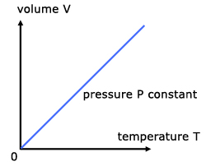

* The relationship between the volume and temperature of a gas is called **Charles’ Law.**
* States that the volume of a fixed mass of gas is proportional to its temperature when the pressure is kept constant.

**Charles’ Law * Memorize**

**Vi = Vf at constant pressure[T1 & 2 must in K]**

**Ti Tf [ V 1 & 2 must be the same]**

**[Units for Volume: mL, L, cm3]**

The volume of a gas is directly proportional to its temperature in kelvins, provided the pressure and the amount of gas remain constant.

The Gas Laws – Boyle’s Law, Gay-Lussac’s Law, and the Combined Gas Law

# Boyles’s Law

* **Robert Boyle** [1627-1692] stated that the volume of a given amount of gas, at a constant temperature, varies inversely with the applied pressure – in other words, as external pressure on a gas increase, the volume of the gas decreases by the same factor.

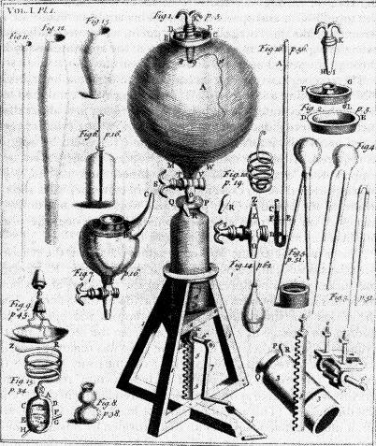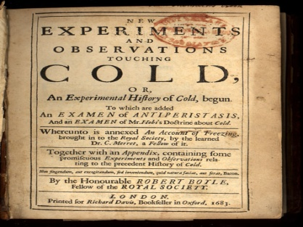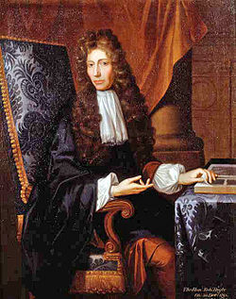

### boylesVolume-Pressure Relationship

* The data plotted in the above figure, seems to show an inverse relationship.
* Mathematically, the proportionality sign (**~**) can be removed by introducing a proportionality constant (**k**)

V ~ 1/P

V =1/P x k or PV=k

For the gas sample at its initial conditions (i): PiVi = k

If the gas sample is then subjected to a change in pressure,

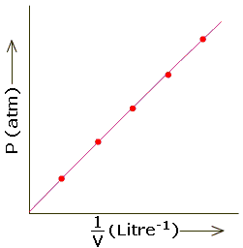as it final conditions (f):PfVf = k

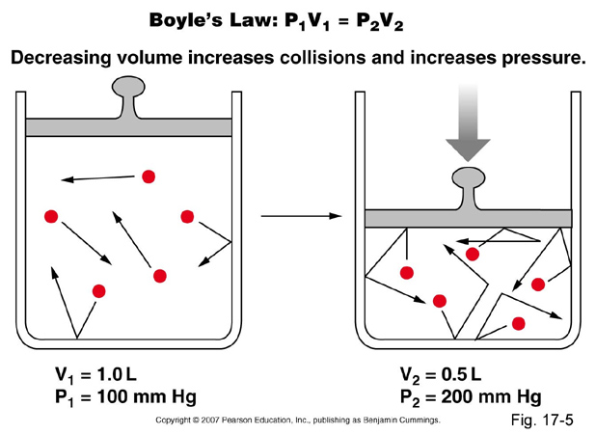

* See figure 3 on page 333

**Pi Vi = Pf Vf  at constant temperature* Memorize**

To summarize, as the pressure of a closed system increases, its volume decreases.

[Assume constant temperature and number of moles is fixed]

**Units Used:**

**P 1 & 2 = kPa, mm Hg, mm Torr, atm**

**V 1 & 2 = mL, L, cm3 [1mL=1cm3]**

**(Units must be the same on both sides of the equation)**

See ***Sample Problem 1-2*** *–* ***pages 334-337***

*Calculating Using Boyle’s Law and Charles’s Law*

Try ***Practice – see page 335-338***

Questions ***#*** 1-4 and #5-9

*Read - DID YOU KNOW?*

Gas Mixtures and the law of Partial Pressures

* Most naturally occurring gases are mixtures.

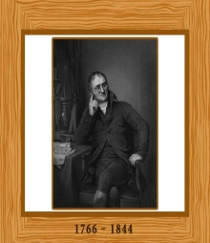**Ex.,** air, volcanic eruptions

* John Dalton was a scientist was interested in the behavior of gases.
* He noticed that air at higher temperatures could “hold” greater concentrations of water vapour than air at lower temperatures.
* The work on water vapor led him to study the pressures of air and water vapour mixtures.
* Dalton used the term **partial pressure** to refer to the pressure that was exerted by each of the gases in a mixture.

# The Law of Partial Pressures

* Dalton’s extensive studies led him to develop a law that has become known as **Dalton’s law of partial pressures.**

**Dalton’s Law of Partial Pressure**

The total pressure of a mixture of non-reacting gases is equal to the sum of the partial pressures of the individual gases.

**Ptotal = P1 + P2 + P3 + ...,**

* The law indicates that the total pressure of a mixture of gases is the sum of the pressures of each gas in the mixture.
* 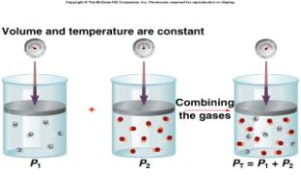The gases must not react, and the pressure units must be the same.

See ***Sample Problem 3*** *–* pages 339

*Calculating Using Dalton’s Law*

Try ***Practice –*** see page 339

Questions ***#*** 10-12

Read:**Applying Dalton’s law** *–* page 340

Read: **Henry’s Law: The Relationship between Solubility and Pressure** - page340-341

See **Section 4.14 Questions –** see page 341

**Questions:** # 1-9

**4.15 *Explore an Issue:***

***Canada and the Kyoto Proticol***

Read pages 343-349 and **Summarize**

*Read - DID YOU KNOW?*

See ***Understanding the Issue*** –*see page* 349

Questions: # 1-6

**4.16 Air Quality Solutions – Your Role**

Read pages 350-356 and **Summarize**

*Read - DID YOU KNOW?*

See ***Section 4.16 Questions*** –*see page* 356

Questions: # 1-6

**UNIT 4 SUMMARY**

**Be Familiar with; *Key Terms;* on page 359**

**Be Familiar with; *Problems You Can Solve;* page 360**

**Be Familiar with; *Key Equations;* page 360**

**UNIT 4 REVIEW Question’s: pages 363-366**

**Try Questions: #1-30**