SPH3U – Circuit Analysis 02

**Determine all V, I, R**

|  |  |  |  |  |  |  |  |  |  |  |  |  |  |  |  |  |  |  |  |  |  |
| --- | --- | --- | --- | --- | --- | --- | --- | --- | --- | --- | --- | --- | --- | --- | --- | --- | --- | --- | --- | --- | --- |
|  | |  |  |  |  | | --- | --- | --- | --- | | Name | V (V) | I (A) | R (Ω) | | R1 |  |  |  | | R2 |  |  |  | | R3 |  |  |  | | Total, R0 |  |  |  | |

|  |  |  |  |  |  |  |  |  |  |  |  |  |  |  |  |  |  |  |  |  |  |  |  |  |  |
| --- | --- | --- | --- | --- | --- | --- | --- | --- | --- | --- | --- | --- | --- | --- | --- | --- | --- | --- | --- | --- | --- | --- | --- | --- | --- |
|  | |  |  |  |  | | --- | --- | --- | --- | | Name | V (V) | I (A) | R (Ω) | | R1 |  |  |  | | R2 |  |  |  | | R3 |  |  |  | | R4 |  |  |  | | Total, R0 |  |  |  | |

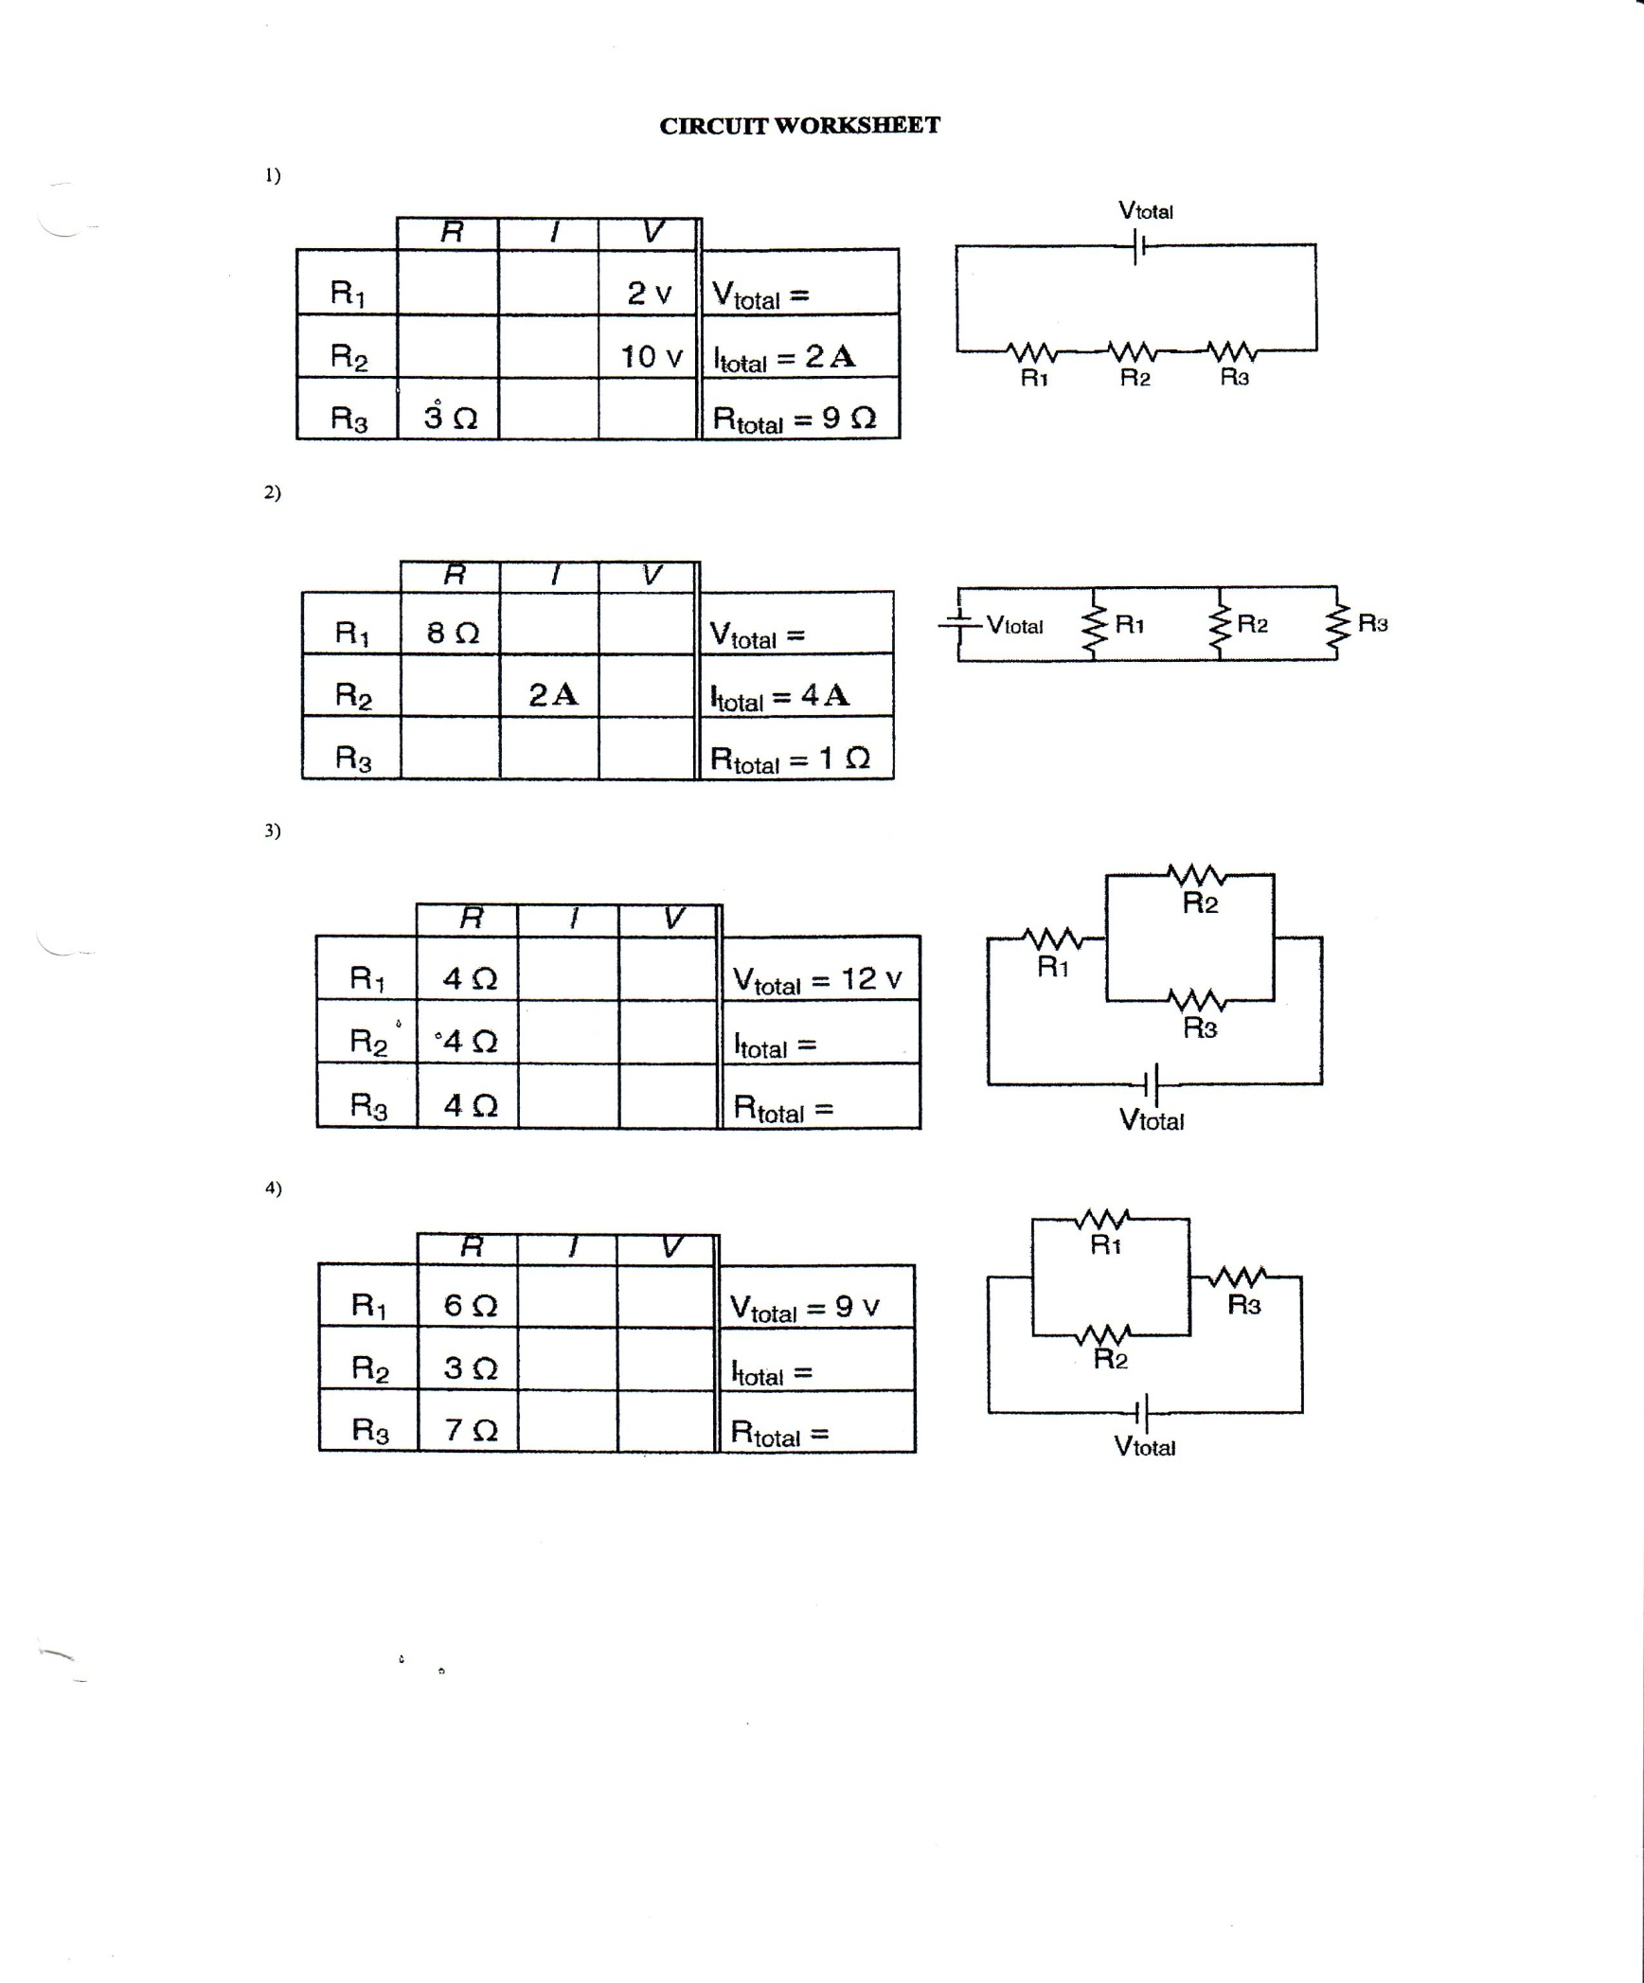

**Numerical Answers:**

|  |  |  |
| --- | --- | --- |
|  |  |  |